DEFINITION MENU

Introduction

The Sejour definitions menu is the most important part of setting up the software. A good understanding and knowledge of these definitions is essential to making the best use of Sejour.

USERS

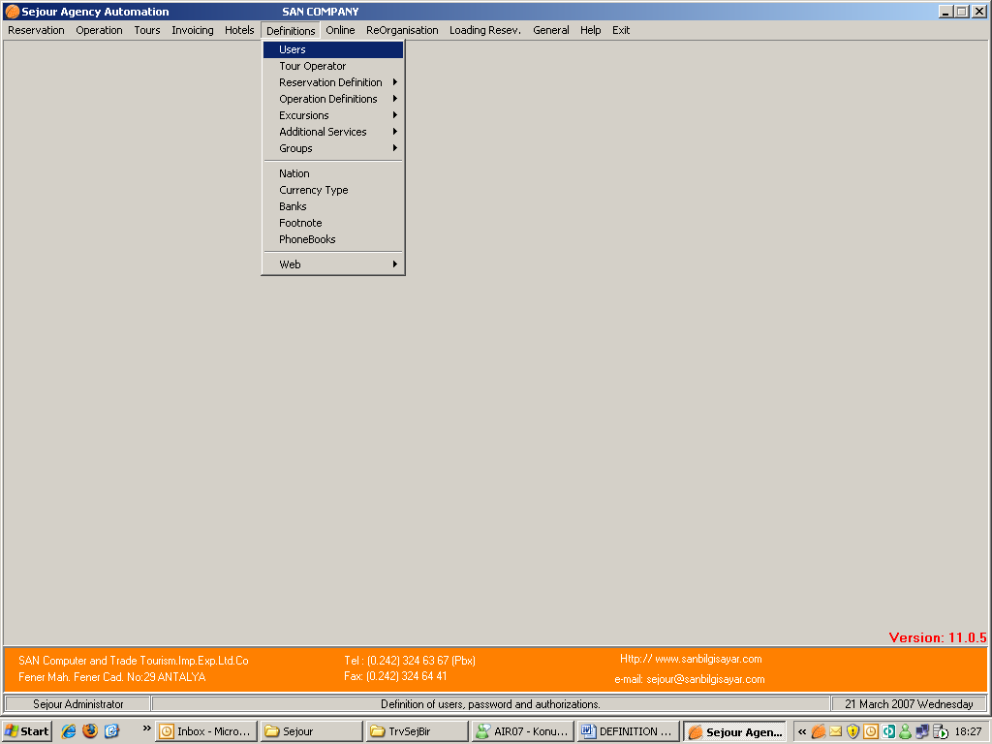

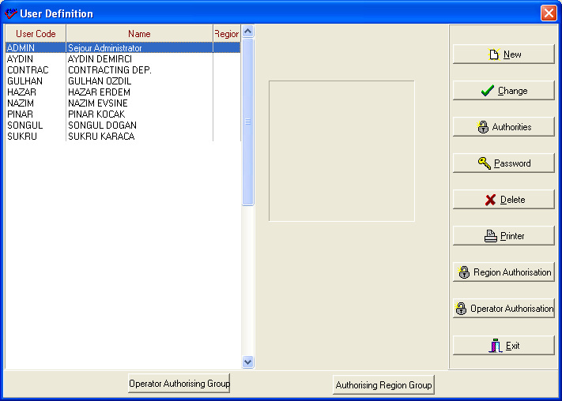

Here you can enter details of the people who access Sejour. A username of up to 8 characters can be entered with a password, which can be blank, but this is not advised.

San Sejour Ltd does not keep a record of your usernames and passwords, and you are advised to keep a written record in a safe location. It is especially recommended that you keep a record of your ADMIN user account.

User names are used in reports of booking entries, for examples, and will appear on the bottom of voucher or request forms that you will send to your other agencies and suppliers.

The main functions are:
New :

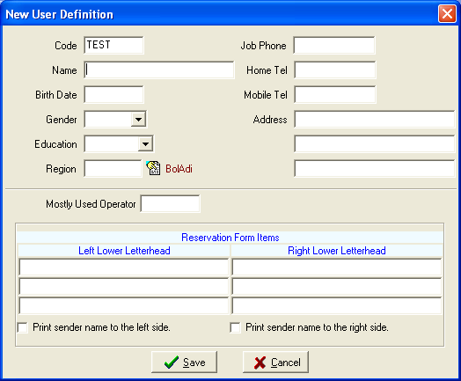

To be able to define a new user you should click ‘ New ‘ button to access the page above .The CODE field is the user name that will be used to log onto Sejour, up to a maximum of 8 characters. Beside that you can enter personal information of the user for just information.
If you write the operator that this user work mostly , the user will gain time when he / she enters reservation page.
If you enter some text in the “Reservation Form Items” table, it will appear on any reservations.

Note: The user password and access permissions are set in another menu.

Change:

This menu is very similar to the “New User” menu, and can be used to modify details of your user accounts.

Note that you cannot modify information in the ADMIN account, other than the password. The ADMIN account should not be used for except for maintenance of the software and it’s databases.
Authorities:

Used to setup access permissions to different parts of the program for different users. For instance you may wish to prevent reservation staff having access to operation information.

The permissions table users a directory-like hierarchy, and permissions are “toggled” by selecting the function and pressing the SPACE BAR.

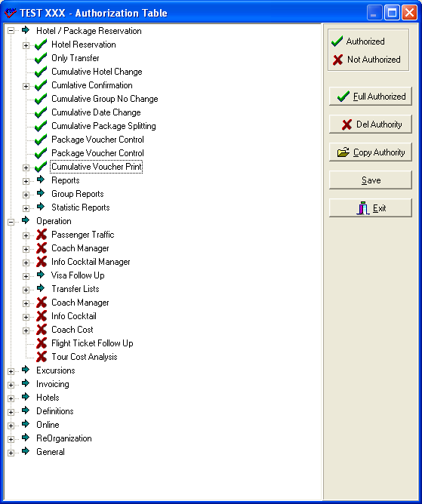

Notice that the user TEST has completed access to reservations menu, but has no access to the Operation Menu (for example).
The user permissions can be copied from the user to an another.
When you want to give full authorisation to a user you can do it by ‘ Full Authorized ‘ button quickly.

Password:

Sets the user password and expiry date.

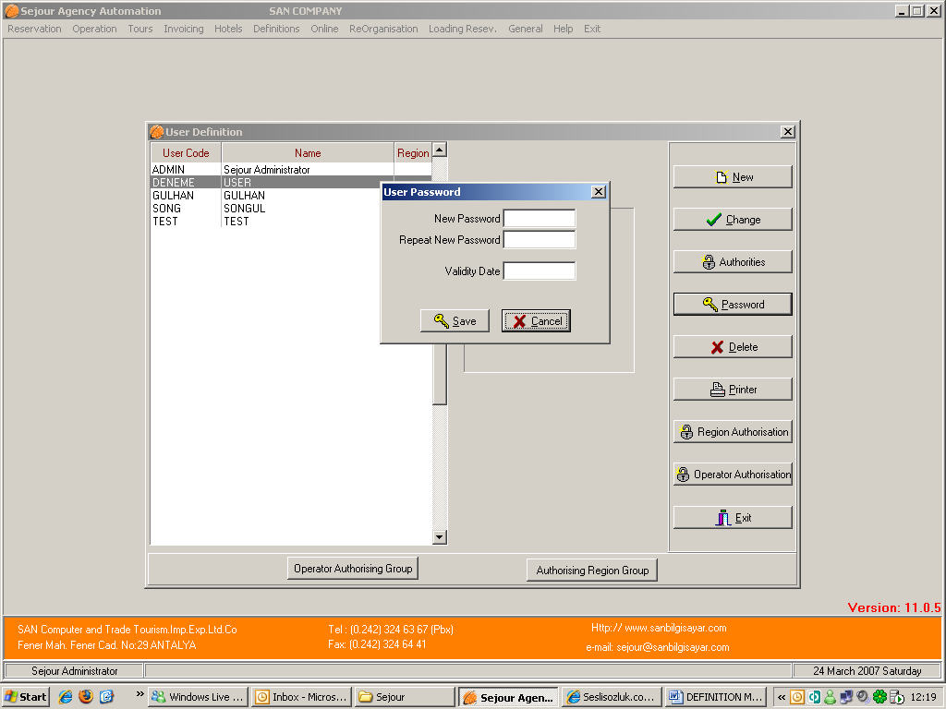

Here we have the password entry for the user TEST

After entering password of the user twice if this user is a seasonal staff you can write the date that is the end of the season so after this date he / she can not be able to log onto Sejour without editing by an Administrator.
For unlimited time access to Sejour, leave the validity date BLANK.

Delete:

Removes all user information. This command is not reversible! If you accidentally remove a user, you will have to restore the account from a recent database backup.

Region Authorisation :

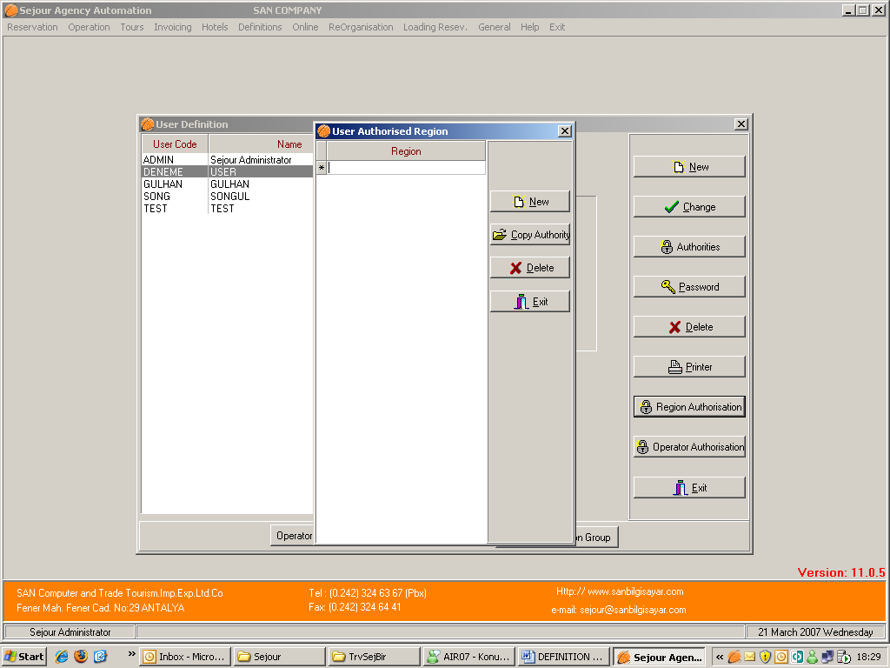

When you define regions here for a user , this user can not access the other region’s information.

Operator Authorization:

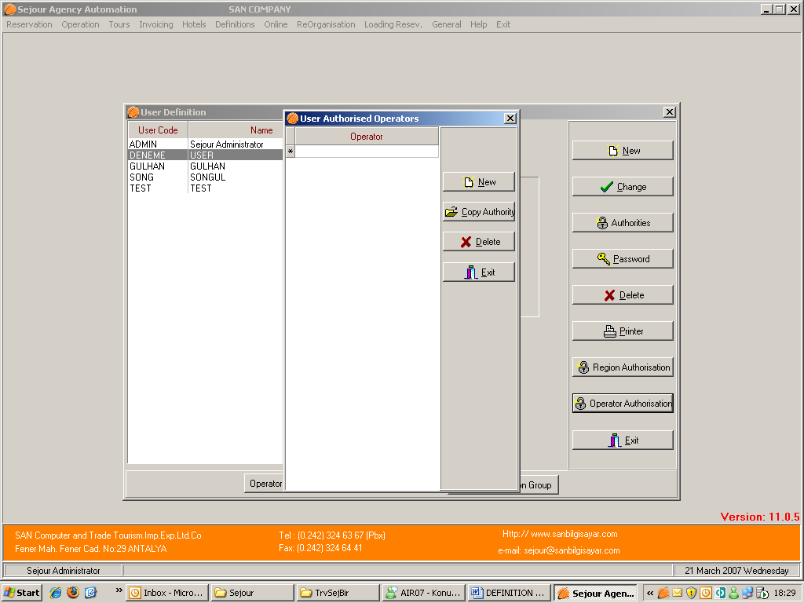

When you define operations here for a user, this user can not access the other operation’s information.

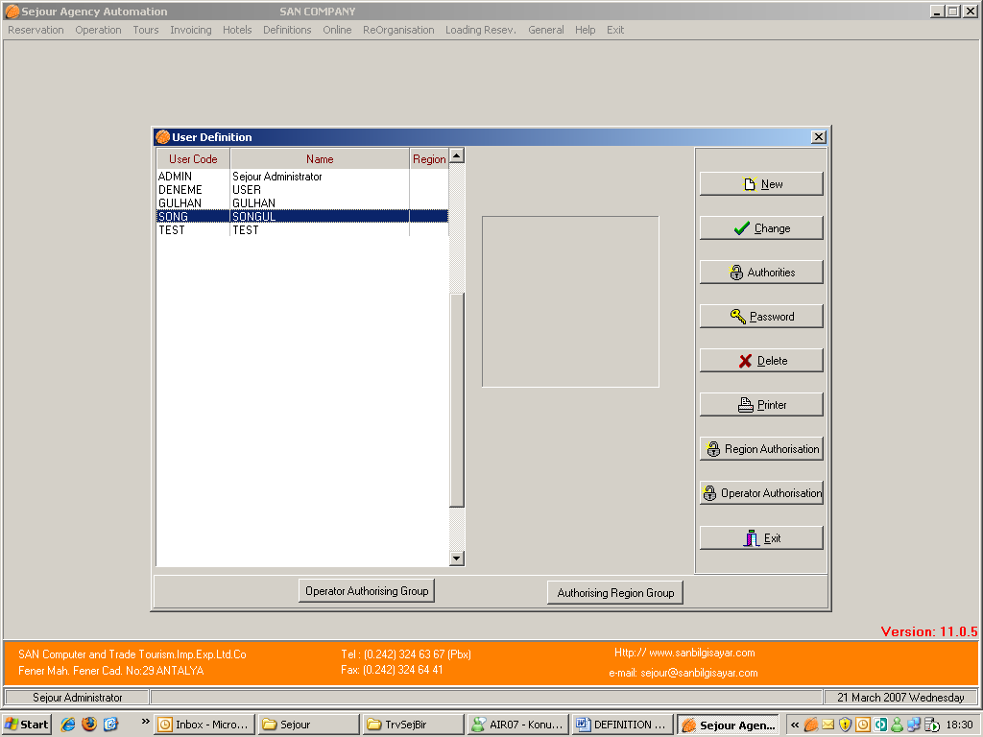

For operator or region authorization you can also form an operator or region group consisting of more than one operator or region by using ‘Operator Authorising Group’ and ‘Authorising Region Group’ butons.

TOUR OPERATOR
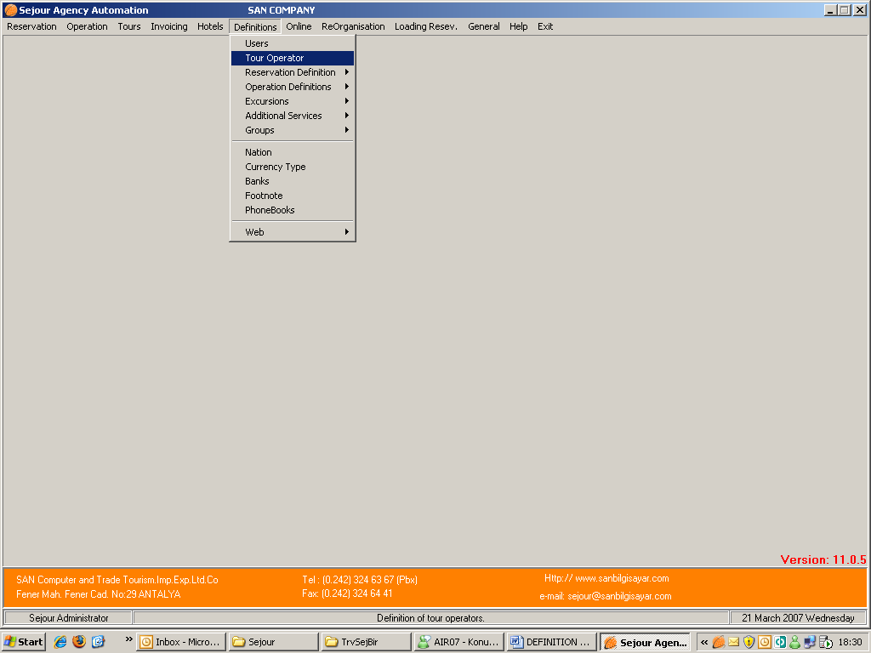

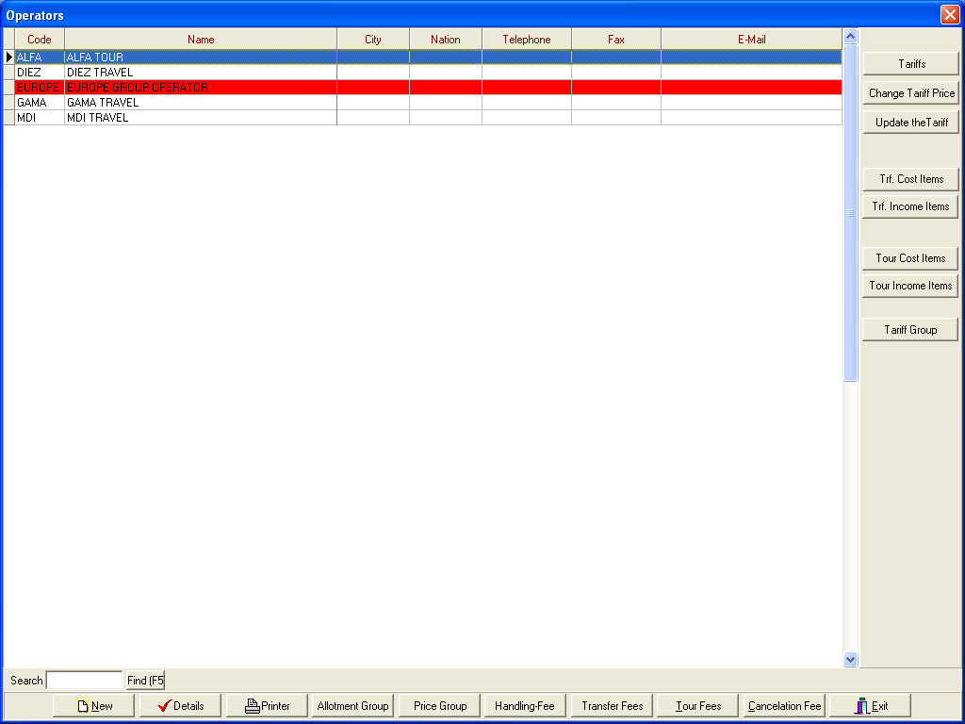

Here you can see your partner tour operators and agencies in overview.

Sejour handles tour operators as individual operators, or as groups of operators (explained later). Groups of tour operators are highlighted in red.

The function keys seen along the bottom, can also be accessed from the “Details” window seen here:
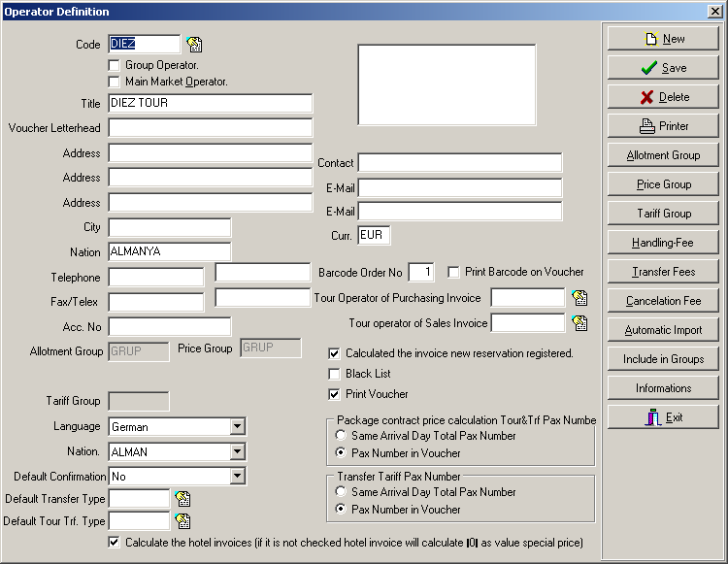

The important entries here are:

- The logo of the tour operator, which must be in Windows Bitmap format (175 x 85 pixels).
- Group Operator: If you have more than one tour operators which use same hotel price , same hotel room allotment and same tariff you should form imaginary tour operator and check ‘Group Operation’ option. This tour operator in this example above is not a group operator but it is combined to GRUP group operator and you can see it in this detailed card.
- The default currency used in transactions (here EUR).
- The “Language” and “Nationality” (this means that the German language will be used for some printed material). The nationality will appear automatically when you make a hotel or tour reservation. It can be changes manually if necessary.
- The “Default Confirmation” is the confirmation default status after making a reservation.
- Default Transfer Type :When it is checked , while you are saving your reservation you will see transfer type as you choose here and the calculation of the transfer of this reservation will be according to this transfer type.
- The checkbox “Calculate an invoice for each new reservation” means that invoices will be calculated as they are entered into Sejour.
- Black List Option is for tour operators which do not make any payment to your agency that if it is checked , any data of this operator can not be entered into Sejour by one of your staff.
- Print Voucher Option is for printing voucher for hotel reservation by Room Reques Form Button or shortcut key F4.If this option is checked , you can print voucher for your hotel reservation but this option is not related with voucher form in Additional Service in Reservation page.

Tour Operator Of Purchasing Invoice – Sales Invoice : The Tour Operator name used on sales and purchasing invoices can be different from the name on the voucher letterhead . If they are different, then they can be entered here.
Calculate The Hotel Invoices ( If It Is Not Checked hotel invoices will be calculated ‘ 0’ as value Special Price ) : If you want to calculate just transfer fees without hotel accommodation price in reservation card you should leave the check box blank so on invoice detailed list you will see accommodation price as ‘ 0’

The functions on the right hand side this are now discussed:

Allotment Group : To be able to define Allotment Group you should be in a group operator’s card.
The most important point in defining Allotment Group is to choose the operators which will use same room allotments .
Price Group: You should choose the operators which will use same hotel prices.
Tariff Group: You should choose the operators which will use same transfer and tour prices.

* Group operators will be explained in more detailed of hotel contracts.

Handling Fee: (shortcut key ALT + H)

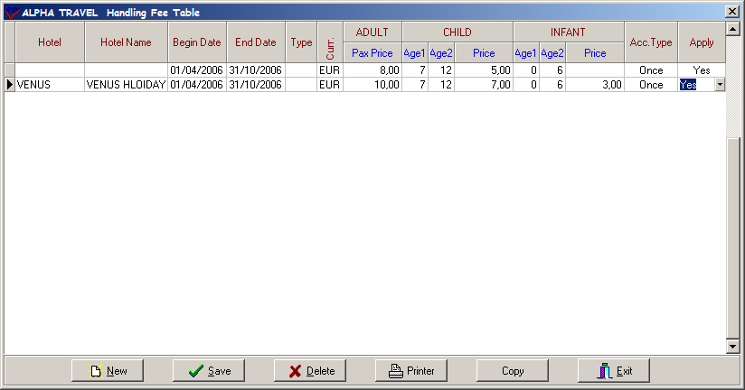

Here we have details of the Handling Fee for Medico Flug Reisen

As in most parts of Sejour, when the “Hotel” fields are blank, then the data will apply to all hotels. Here the handling fee is 5 Euros for adults for all hotels, except the Nefertari Hotel, for which there will be a handling fee of 8 Euros

Children between the age 7 – 12 are % 50 0-6 are free, and the “account type” is “Once”
If you apply handling fee daily instead of once you can choose ‘Daily’ as account type.

The “Apply” = YES means that you want to use the data in calculations. NO means that you don’t want to use the handling fee, but you don’t want to delete it from the system.
Transfer Fee: (shortcut key ALT + T)

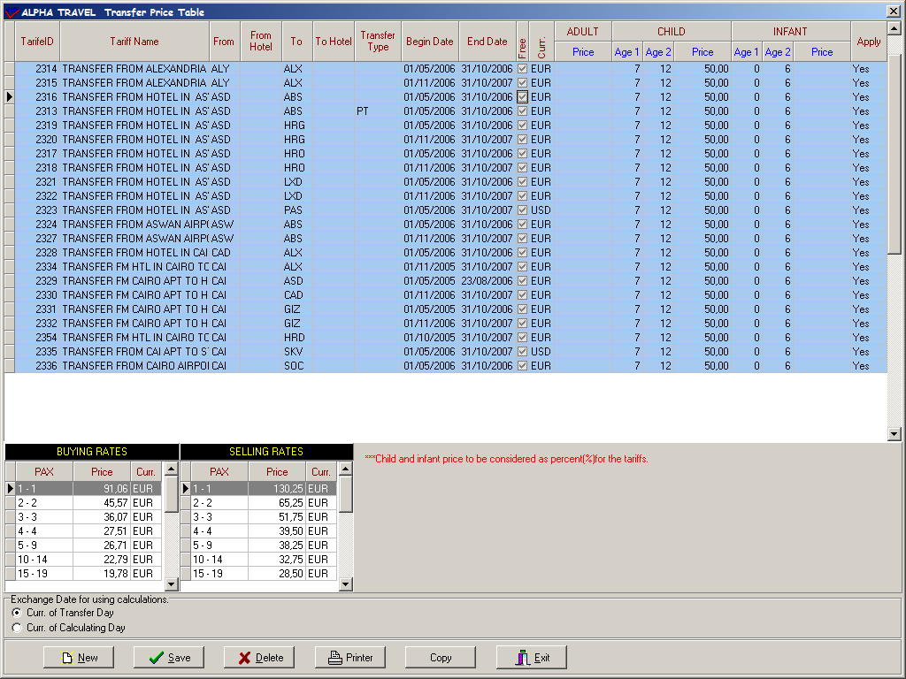

Here is the transfer fee table for the tour operator Medico Flug Reisen .The tariffs entered in tariffs page(that will be explained later) are send to this page after updating

On this page you see Tariff ID number that is given by the system , tariff name , destinations , transfer type ,season date , currency and child reduction .You see adult transfer fee on left bottom of the page.

There are two choices for calculating exchanges rates:

1) “Curr. of Transfer Day” i.e. make the calculation using the exchange rate that applies on the day of the transfer.
2) “Curr. of Calculating Day” i.e. make the calculation using the exchange rate that applied when the reservations are entered into the system.

Cancellation Fee: (shortcut key ALT + C)

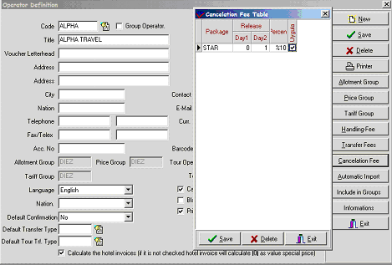

Here you can set a cancellation fee as a percentage for a given window in time.

When the “Package” field is empty, then the fee will apply as a flat rate for all of the packages.

When the “Uygula = Apply” tick box is checked, then the cancellation fee will apply.

When it is NOT checked, the cancellation fee will not be used, but the table data will not be deleted from the system, and can be used later.
Information:

Here you can enter any company footers or headers that will be used on any printer departure information forms.

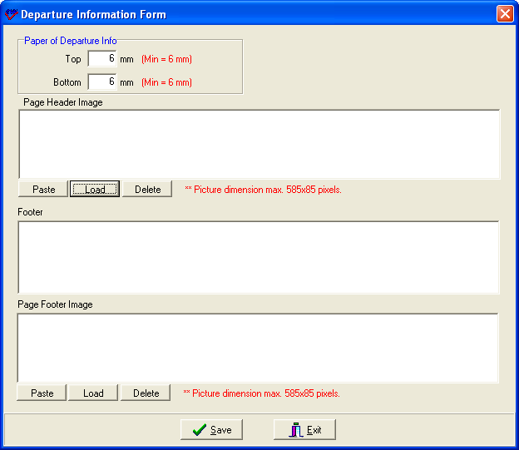

You can cut and paste a graphic, or you can open an existing graphics file.

The graphics file should be Windows Bitmap (.bmp) format, and be 585 x 85 pixels.

Tariffs :

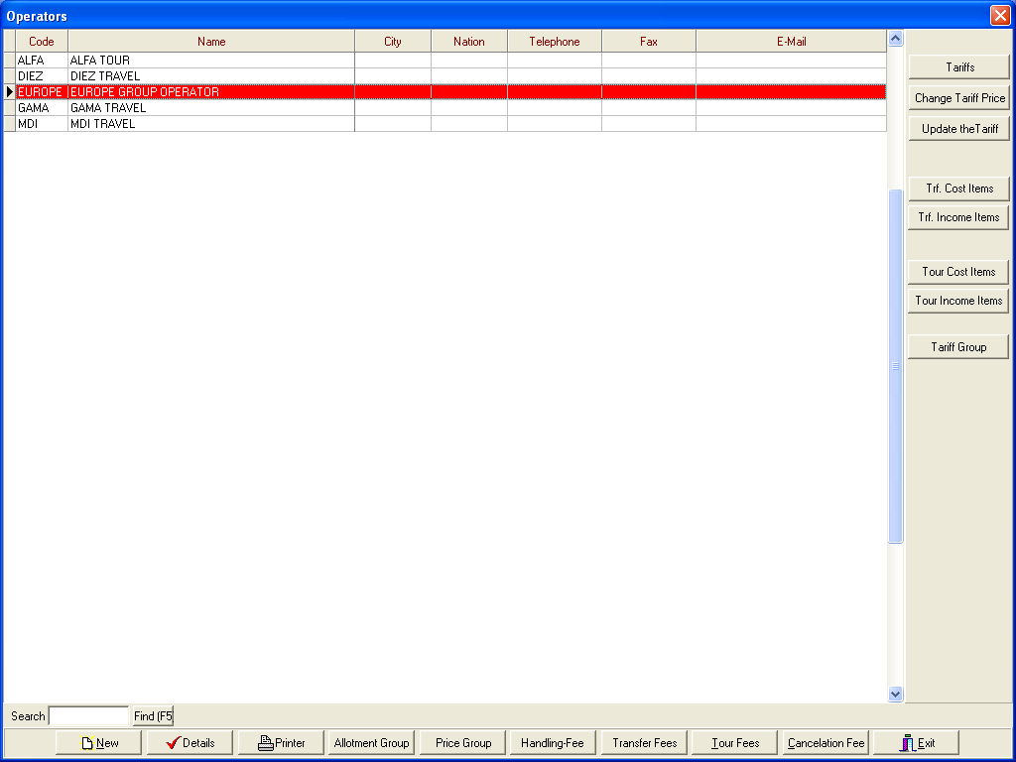

Before entering your tour and transfer tariffs you should enter prices of tour and transfer cost and income items because you are going to form your tariffs according to these costs and incomes.

Transfer Cost Items :

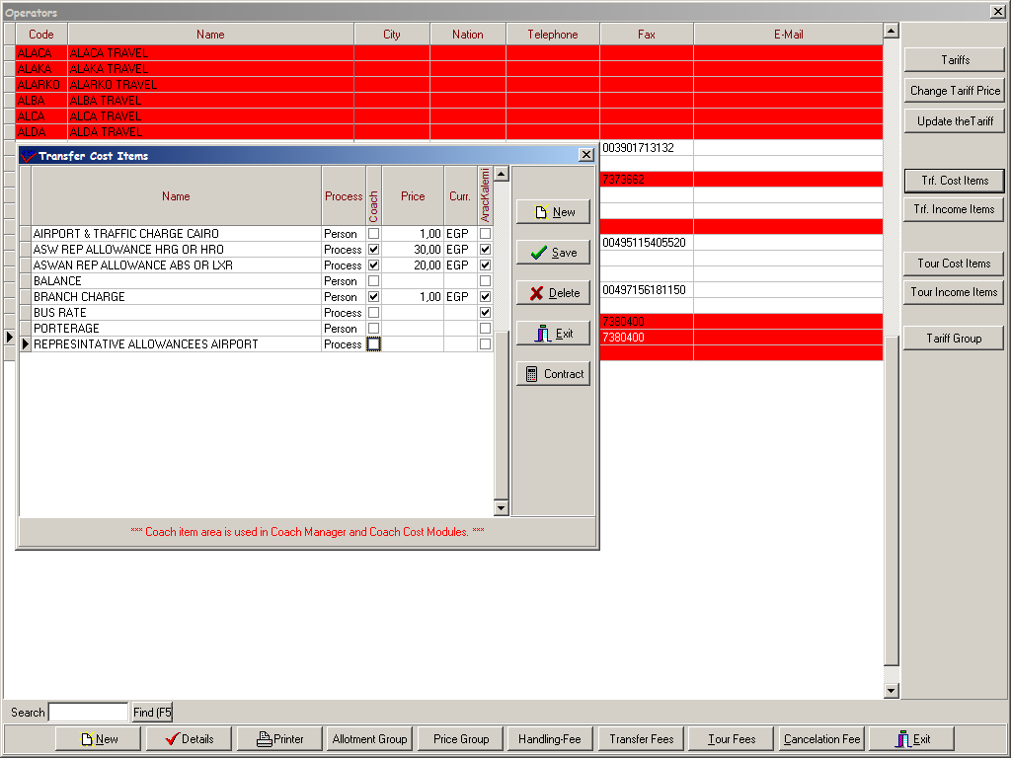

You should define your expenses in a transfer operation .The important point here is whether this expense is per person or per process and you should enter either average price on the chart or contract price by using ‘Contract’ Button as you will see in the example below. If this item is a coach cost item that should be calculated as coach cost you should check ‘Coach Item’ check box.

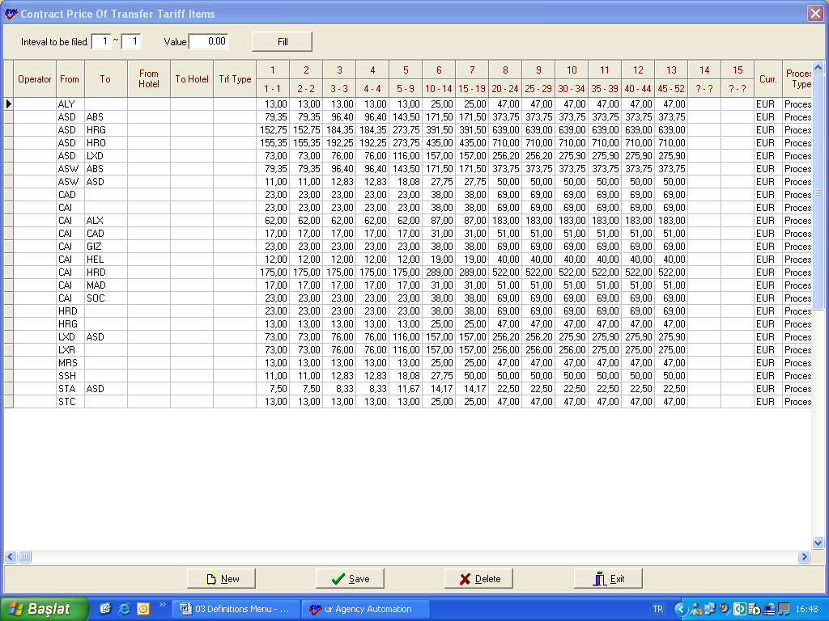

First of all if the price is special for an operator you should define the operator’s name if it is valid for all you don’t need to define any then you should choose destinations and enter the prices according to seats and pax number on the top of the table that is already default in the system.

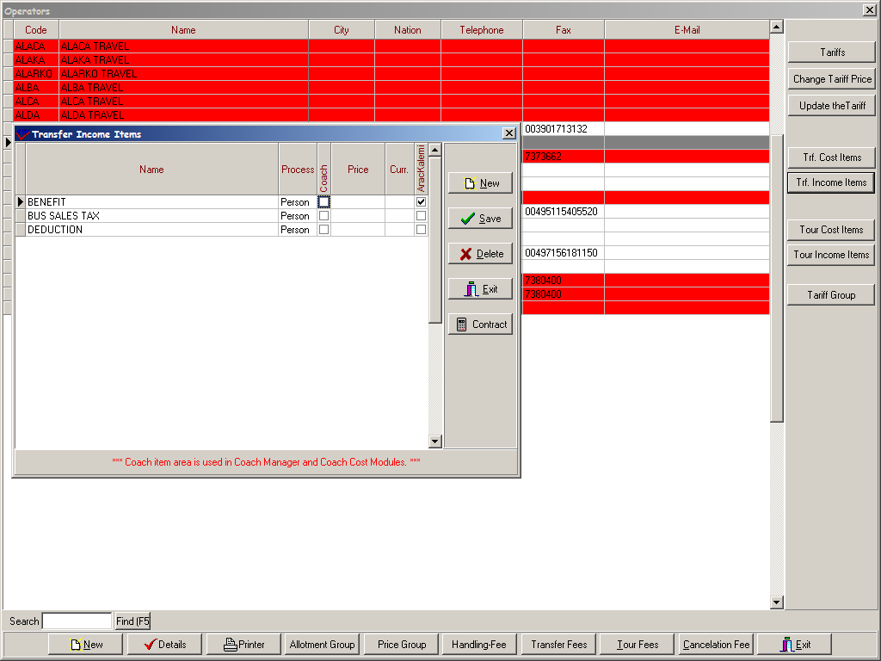

Transfer Income Items window is the place that you can identify your incomes and their prices and also here you should check the check box of the item if it will be calculated as coach item .

Tour Cost Items

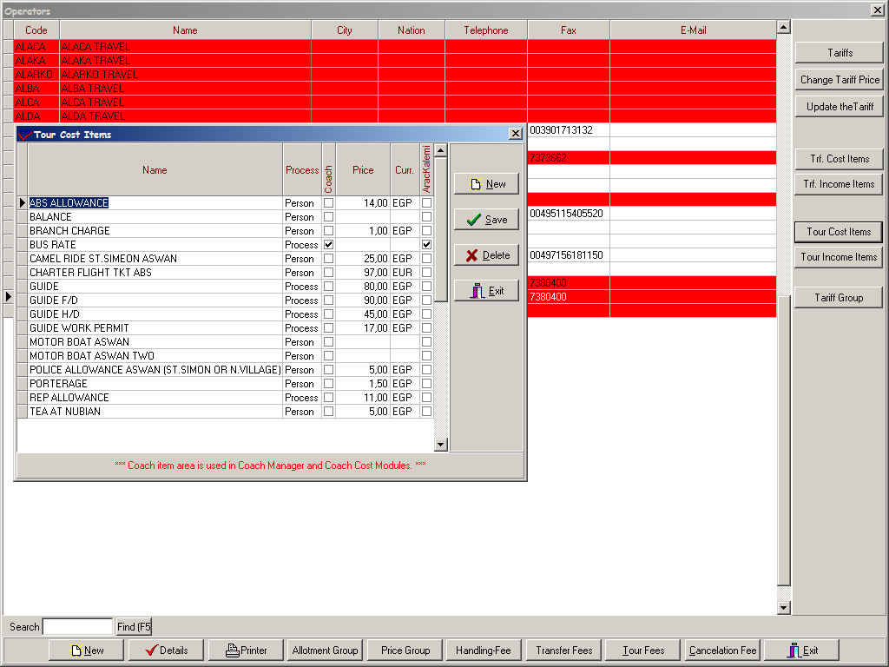

To be able to define tour tariffs you should also enter your tour cost and income items .As in transfer cost and income items you can enter average price or contract price here.

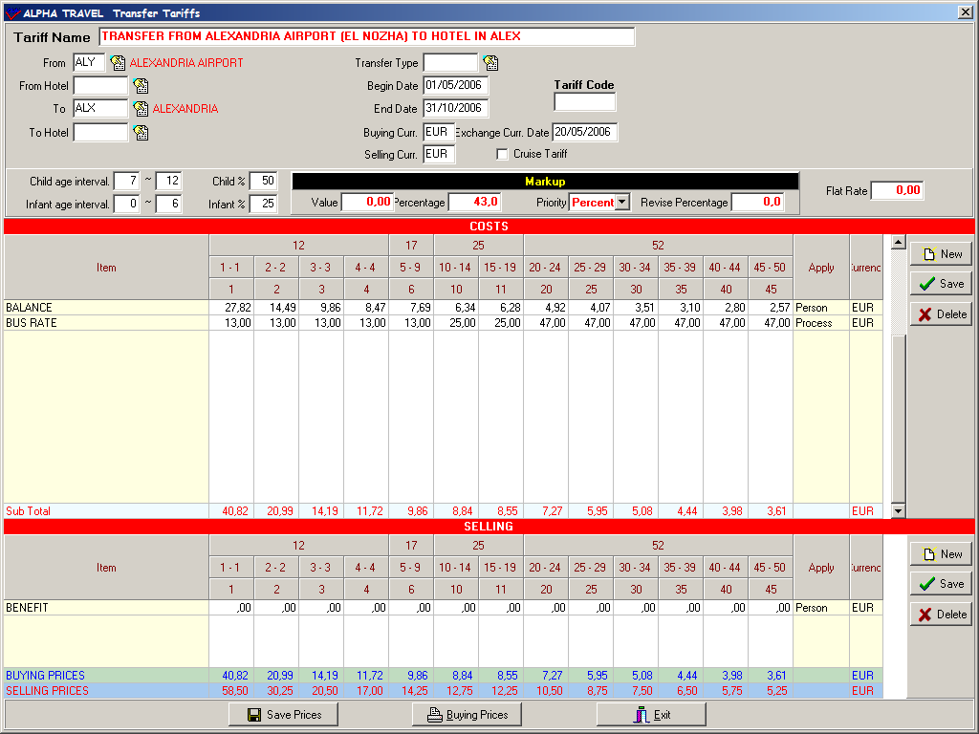

Tariff Name: You should write name of the transfer whose price you enter.
From: You should write the destination that the transfer begins .These destinations are defined in regions part in Operation Definitions before and you choose them by short cut key F2 here
To: You should write the destination that the transfer ends.
If you want to enter the price according to hotels you should define hotel’s name in ‘From Hotel’ and ‘To Hotel’ place.
Next to region part there are other blanks that you should fill in such as ;
Transfer Type : You should choose the transfer type whose price you enter that it is one of the most important place in terms of transfer prices of reservations.
Begin date and End date : You should write the dates here when these prices are valid.
Buying Currency : It is the currency of your cost
Selling Currency : It is the currency that you give to your tour operators and you have opportunity to enter Buying Currency and Selling currency different .E.g. Buying currency is in EGP , buying currency is in EUR.
Exchange Currency Date : In Sejour there is one main currency table to use for any calculation. The exchange currencies can be defined daily basis or monthly, depends on the agency working style. For each tariff list you are already assigning exchange rates, when you open one new tariff table the system automatically creating the “exchange currency date” on the same entry date, but you always have an option to change it to another date.
Transfer Code : This part is used to give a code to be able to order transfer and tour tariffs. When you take ‘Buying Price’ or ‘Selling Price’ list , you see transfer and tour tariffs are ordered according to regions .

After defining the information above you should enter the prices .You can choose the item by short cut key F2 as soon as you choose it , its price comes automatically since you enter it in Transfer Cost Item Part before .After defining all your costs in this part you will see sub – total appears.
As a second step you should define transfer income items.

While you are entering them the system asks you the following question

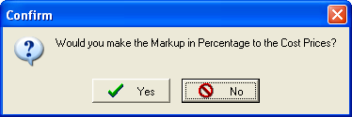

If you click Yes , the system will bring you the table below to be able to determine your increasing rate. If you click No you can enter the increase prices manually.

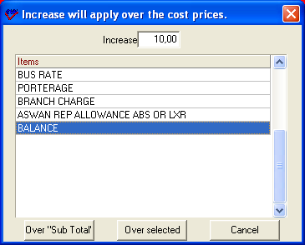

After determining increasing rate you should select the cost that the increase will be applied over or you can apply the increase over sub-total by using the buttons on the bottom of the table.
As soon as you enter increase prices , buying prices will be formed without any mark up .
To be able to form selling prices adding mark-up rate on buying prices by using mark-up table .You can give value or percentage or both in order to add mark –up on buying prices .Beside that after giving mark-up rate you can determine the priority about order so which one you want to apply first you choose it in Priority place .So the system will add the rate you choose first and the system has the ability to round the prices up.
On the other hand there is another way to form selling prices using Flat Rate . By using this part you can give net price for selling prices as independent from buying prices.
After completing prices of adults you can enter children and infant reductions filling in blanks next to mark-up table.
Although this tariff that you form seems one way , it is actually calculated as return (two ways).This means that this tariff is valid for both arrival and departure.
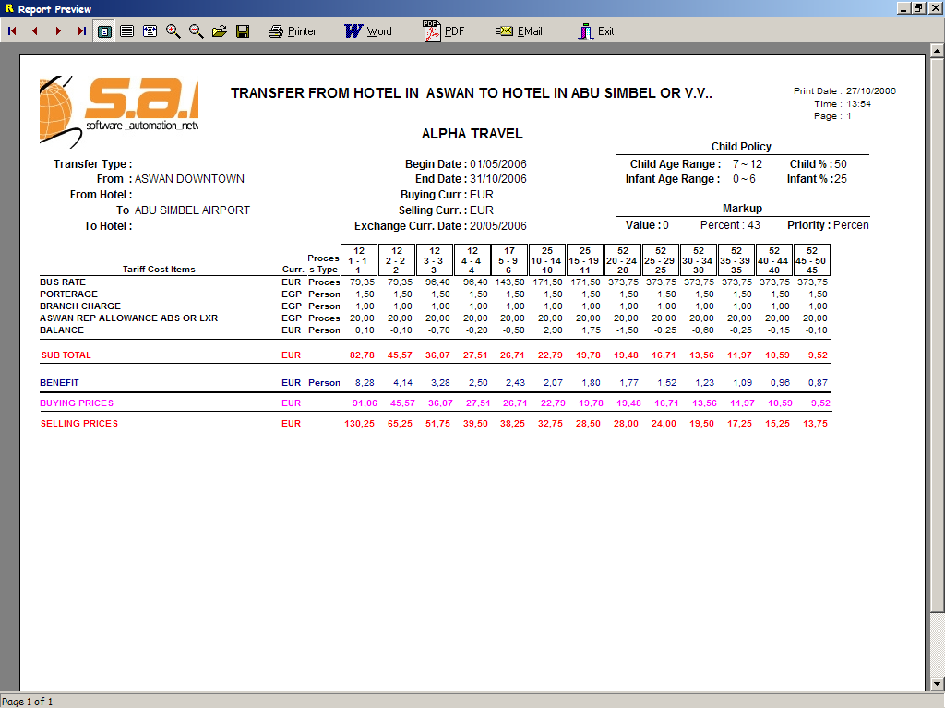

After saving your tariff if you want take a price list of this transfer tariff you can reach it using Buying Prices button on the bottom of the page .
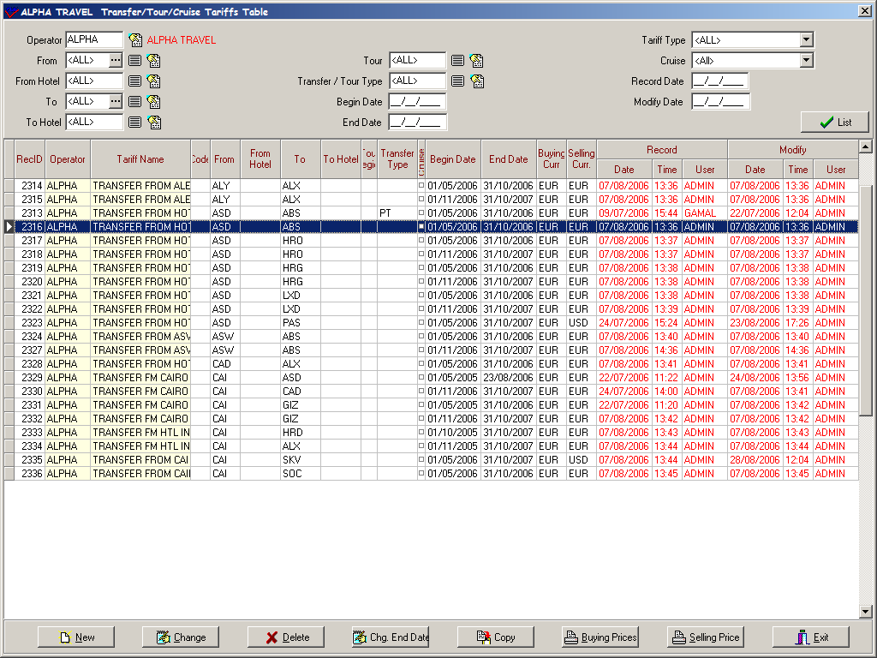

On the other hand after completing prices you can take a total list of all transfer tariffs by Buying Prices or Selling Prices buttons on the bottom of the main tariff page.
When you click one of this button a table appears to be able to write a main header and footer
on your list .Beside that if you want to take a list in USD (e.g.) currency which you actually enter in Euro before you should write USD or EGP in Curr. part to be able to take your list in USD or EGP and then click OK .If you don’t want any header , footer or currency changing on the list you should just click OK without writing anything.

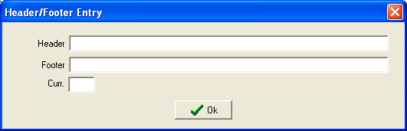

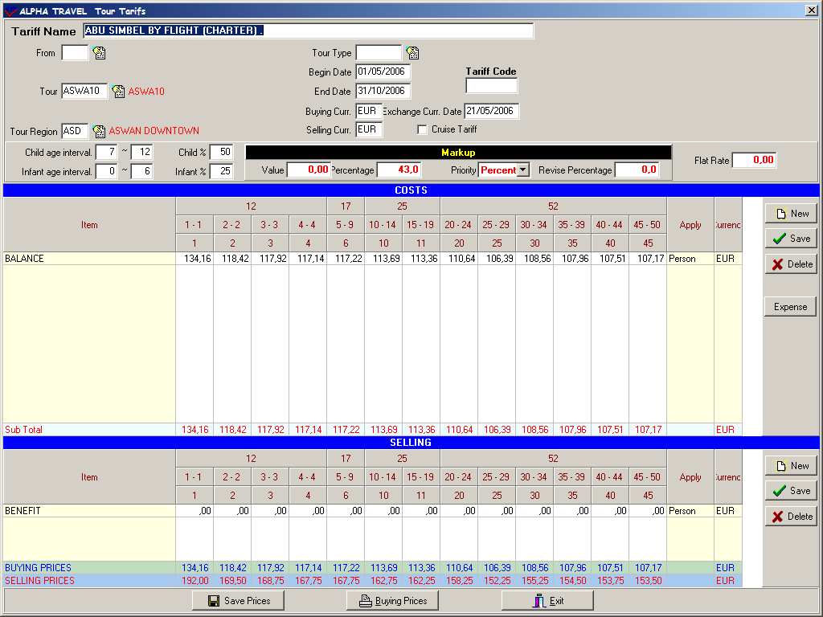

Entering Tour tariff is not much different from transfer tariff . Apart from transfer tariff there is no price differences according to the sales region (“ from” destination in tariff which is displaying the place where the hotels region ) in tour tariff so you can leave the from destination empty in the tour tariffs. We have this column in order to differentiate the price from one region to another region but to define tour region there is another blank to be filled and it never effects the price .This region displays you which region departs from.
Beside that the system brings tour names from Excursion sub-menu (that will be mentioned later) and you should choose them by short cut key F2.

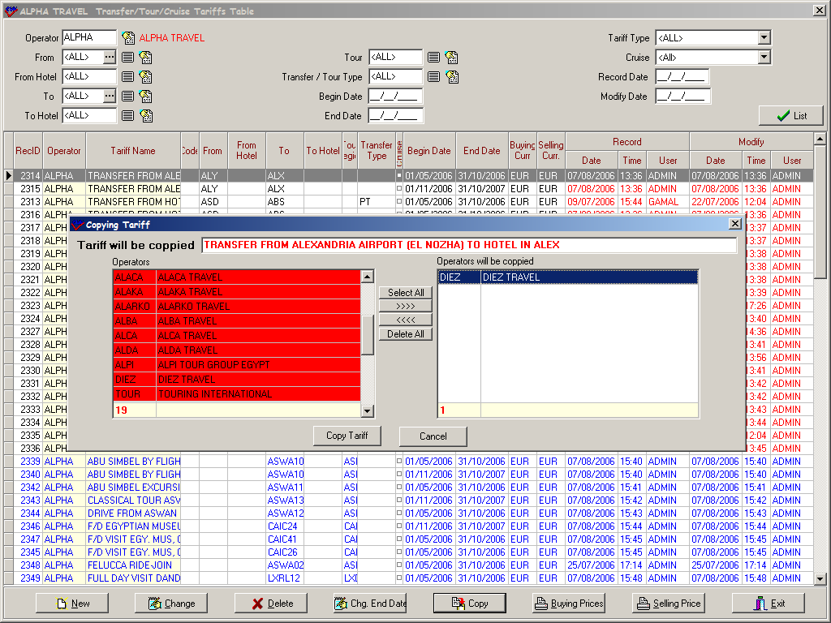

When you want to copy one tariff to another operator you should use Copy button .When the window opens you should select the operators that you will copy the tariff to.
Another button that is much functional is ‘Change End Date’ because you can change end date of even the whole list .But the first thing you should do is to enter begin date before changing date and then When you click this button the system will bring you a table as you see below.

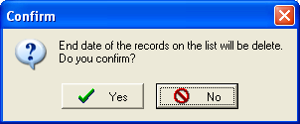

If you click Yes button another table will be brought by the system.

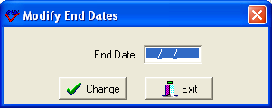

You should enter the new end date here and click Change button and end dates of tariffs will be changed .

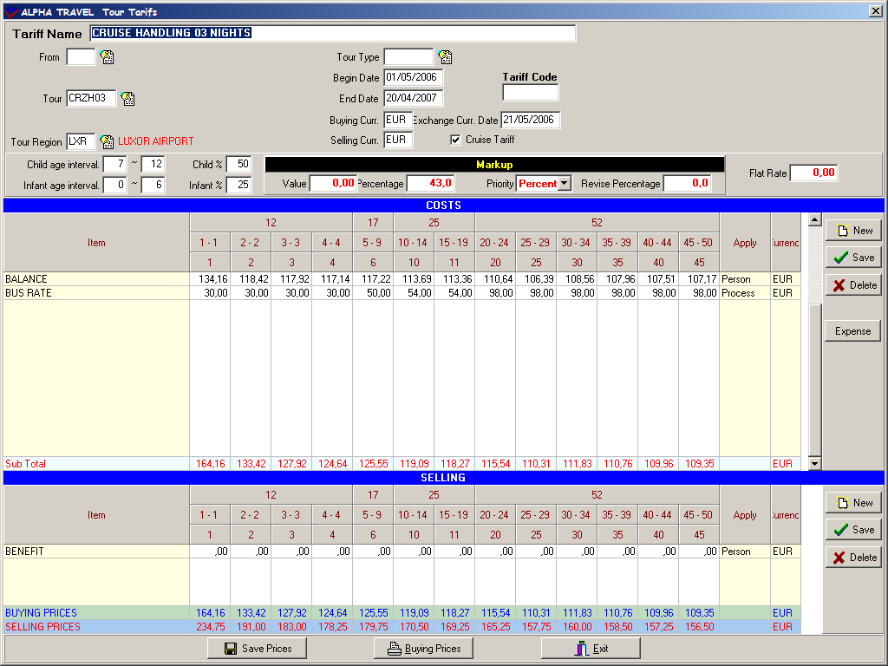

Cruise tariffs are similar to tour tariffs .Like in tour tariff you should choose the cruise tour by F2 because it will be brought from Excursions menu since they are defined before .And the most important thing is check box of cruise tariff .When you check it you can apart cruise tariffs from the others easily as you will see below.

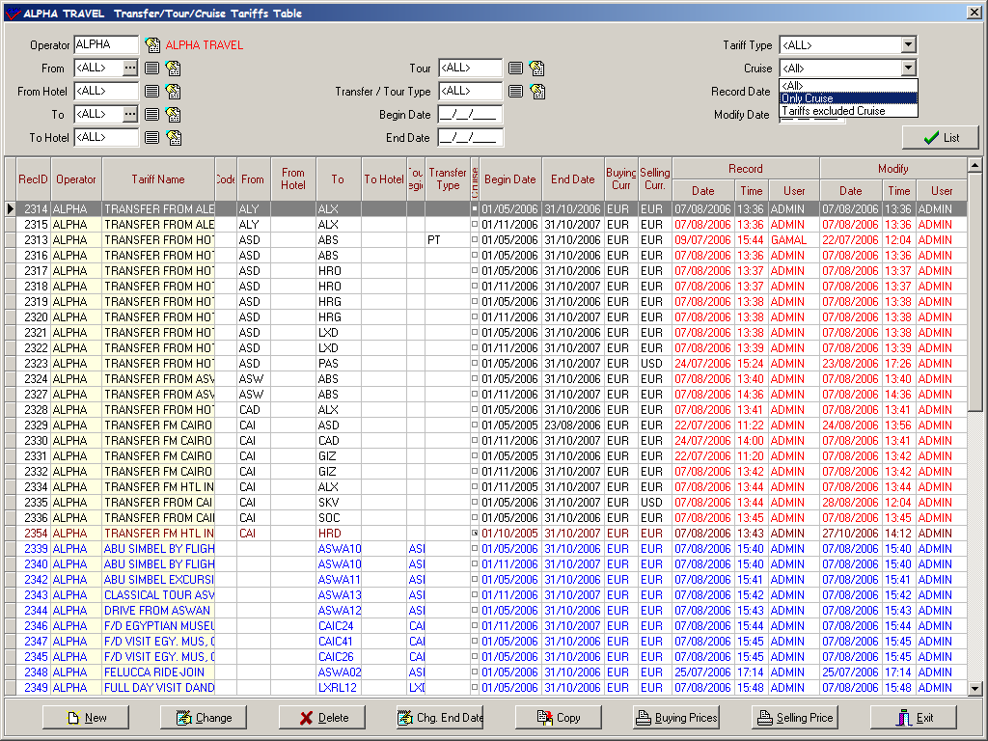

As you see cruise tariffs are in red , tour tariffs are in blue colour .If you want you can filter cruise tariffs easily with an option named ‘ Cruise’ on the right top corner of the page so you can choose just cruise tariffs or just the others quickly.

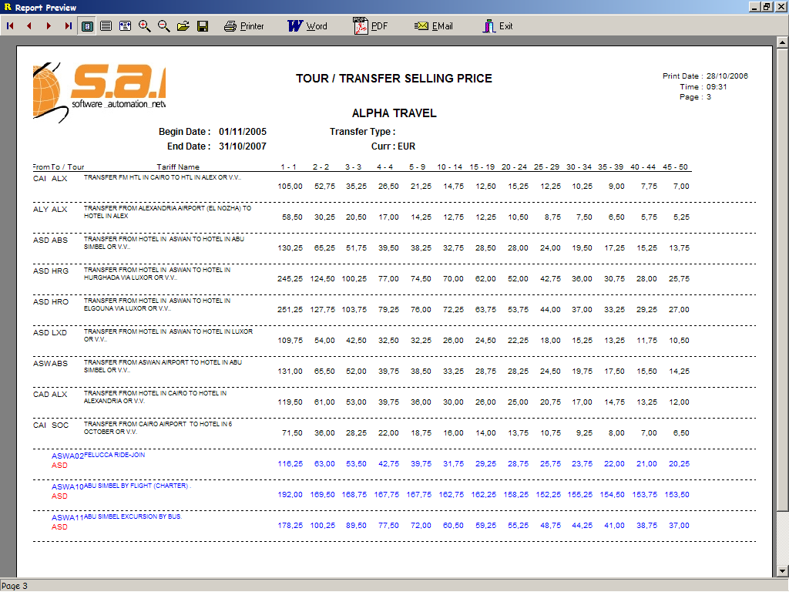

At the end when you print tariff list you see tariffs are ordered as first transfer tariffs , second tour tariffs and cruise tariffs and they are ordered according to regions.

RESERVATION DEFINITIONS

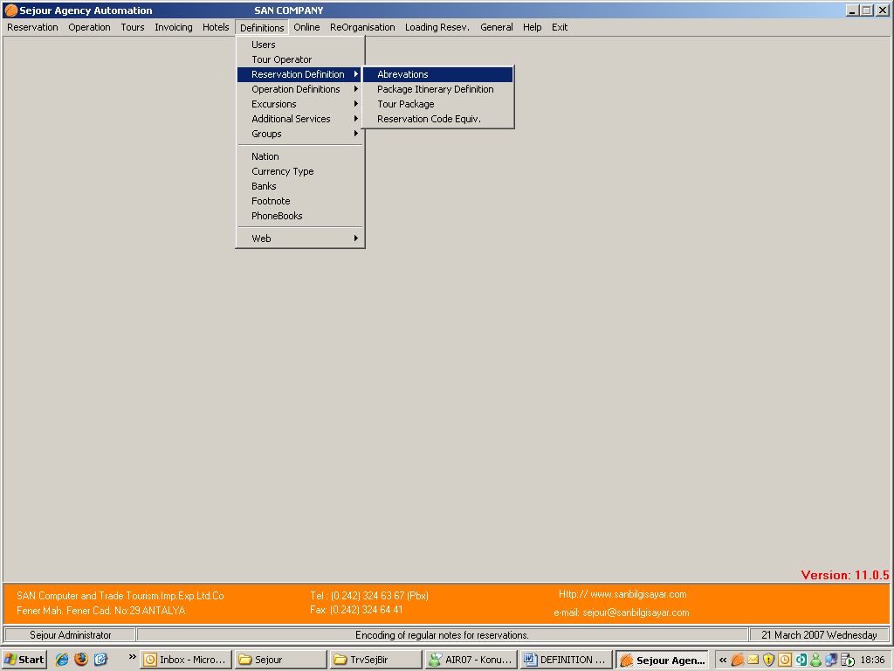

Abbreviations : It gives you an opportunity to write abbreviations and their explanations here once and use them in reservation page in ‘ Hotel Note ‘place writing hotel notes quicker so you will gain time

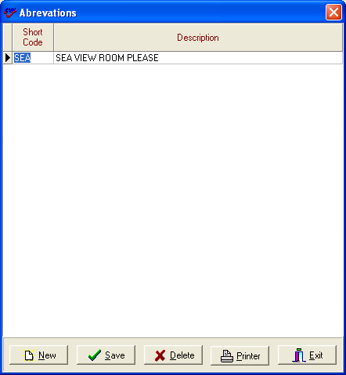

You should define an abbreviation and its explanation as you see in the example above and while you are entering your hotel reservation if you write that abbreviation in ‘Hotel Note’ part as (SEA ) and click ‘Enter ‘ key , you will see your note will be written.

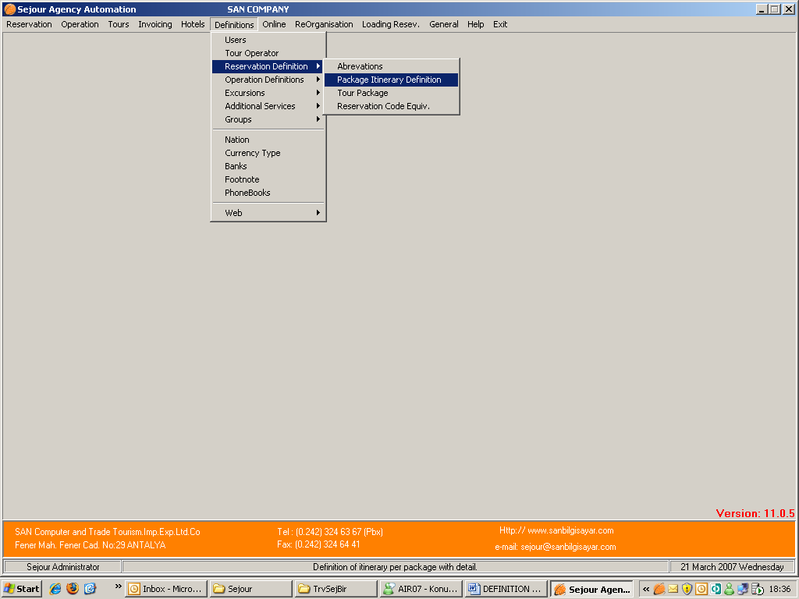

Package Itinerary Definition : You can define your package itinerary day by day in this part as you will see in the example below.

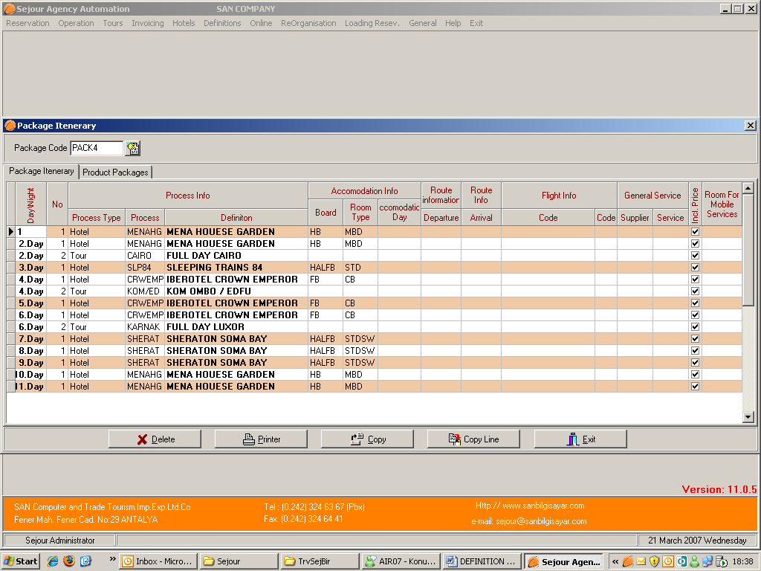

This table is used to define package itineraries .The most important thing that you must do is to select the process type and name of the process. You should fill board and room type parts certainly because you will need it calculating your package hotels after splitting the package you entered in package reservation page.
If the process is mobile one such as train or cruise you should write route information on the other hand if it is domestic flight you should write flight code and flight class code. In addition you should select room for mobile service in the part at the end of the table. It provides that when you split the package the system will take the information as room and calculate it without changing any information in reservation card .If you do not define it , the system will take the room of the package that is entered as DBL room in package season page in hotels menu.
The other point is that if services in the itinerary are not included in the package, you should clear the ‘Incl. Price’ check boxes of services except tours because tours are included in package price.
Once you enter this itinerary you use it splitting packages in your package reservation page .You should fill lines day by day but you can do it easily copying a line to another.
For example : if clients will stay in Conrad hotel for 4 days you define just one line and copy it to rest of 3 lines.

OPERATION DEFINITIONS

Regions :

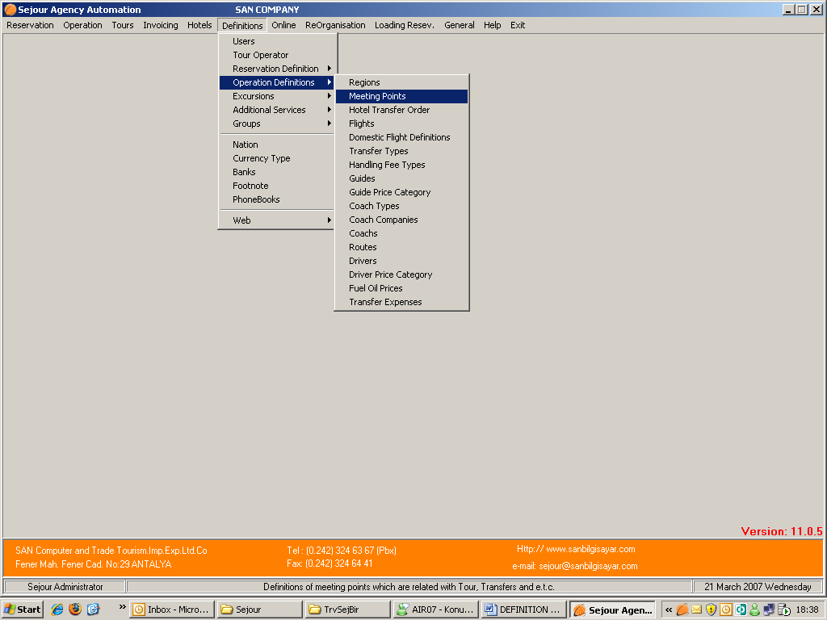

You can define the regions including hotel, airport, transport and tour locations that you will use through Sejour.

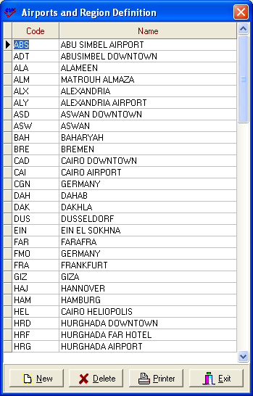

Here you should enter the short codes and names for the regions (cities and towns), where you are working as in the table below.

Because these codes are designed to promote fast entry of data, they are not more than 3 characters.

Regions are also important for reports and analysis of reservations and ticket sales by region. They are also important in organising the order and price of hotel transfers, or tour journeys.

Meeting Points :

Used to define specific locations where the guide and coach or coach and coach will meet or clients will be picked up. These “Meeting Points” are different from “Regions” because they are more localised.

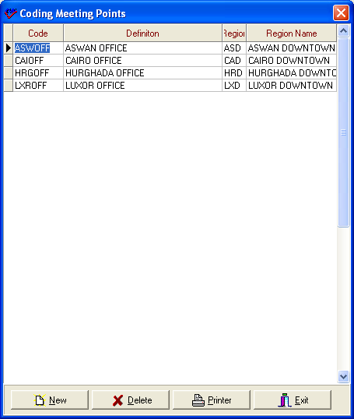

If you do enter meeting points it can help for fast entry of coach operation for transfers and excursions, and if vital if you wish to generate lists for clients which will inform them of their collection times and places.

Flights

Here you can enter details of your arrival and departing flights, with flight numbers, airline, and details of any complementary (back to back) flights.

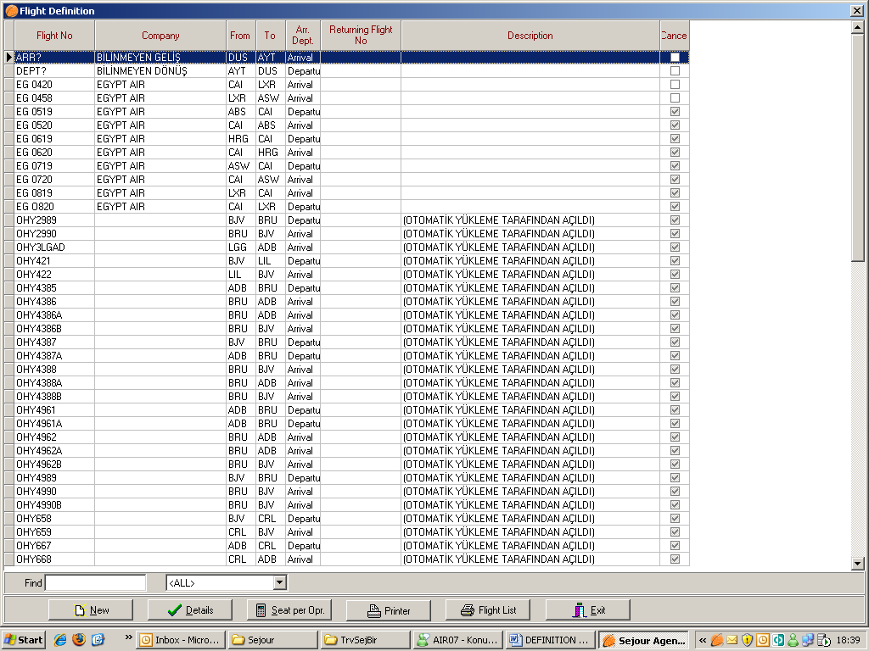

Notice the two “generic” flights “ARRIVAL” and “DEPARTURE”. These can be used as dummy flights if you don’t have flight details at the time of reservation.

Notice the “To” and “From” fields, which you defined in the “REGIONS” definitions sub-menu.

To be able to define a new flight you should use ‘New’ button.

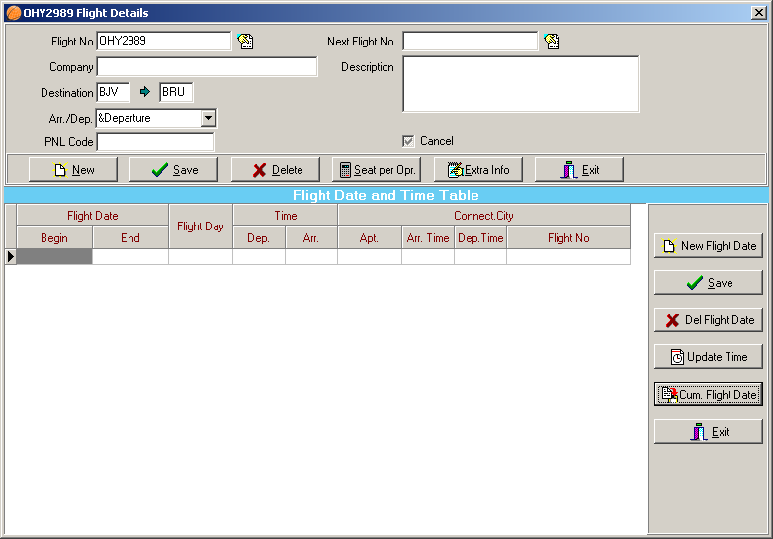

It’s important to define a flight its’ arrival or departure flight (using the “Arr./Dep.” dropdown list). Defining departure flight here you will gain time while you are entering hotel reservation because as soon as you select arrival flight, the departure flight will come automatically.

The “Flight Dates and Time Table” can be left blank, but here details are given .If you have flight in same hours everyday it’s better to write the flight hours here to be able to see reservations with flight hours in passenger traffic page .If you enter timetable after entering your reservations or you have new flight timetable . You should update the time using ‘Update Time’ button because you will need to re-organise airport transfer schedule While you are doing this the system will as you the following questions ;

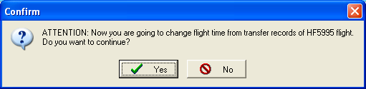

When you choose ‘Yes’

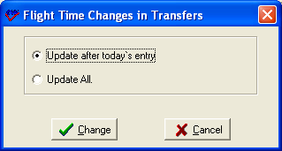

Update after today’s entry: It changes time of flights after today’s entry
Update All :It changes all flight times available in the system before.

Beside that if you have connection flight combined this flight you can define it here as well as you see in main example above so you can see this connection flight in ‘general transfer’ list.

The “Cancel” checkbox can be used to temporarily stop using a flight, without deleting the flight’s records from the Sejour database.

You can enter tour operator flight allocations using the “Seat per Opr.” button:

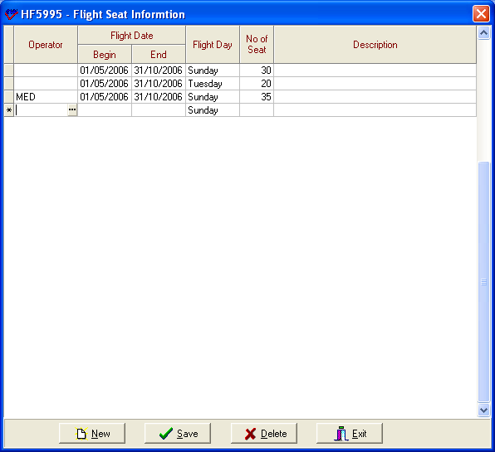

If you have same numbers of seat allotment for all your operators you don’t need to specify any operator but you should write the begin and end date that is valid for allotment , flight day and number of allotment day by day. So you can check your allotments from ‘Flight Occupancy Report’ in Transfer Lists Menu.

The “Extra Info” button can be used to enter different flight codes used by specific tour operators.

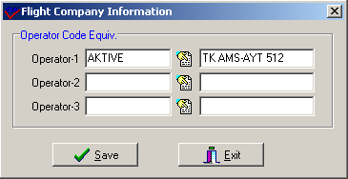

Here the standard flight code is “TK512”, but Aktive Travel have their own flight code.

This feature would probably only be used for automatic importation of reservations
DOMESTIC FLIGHT DEFINITIONS

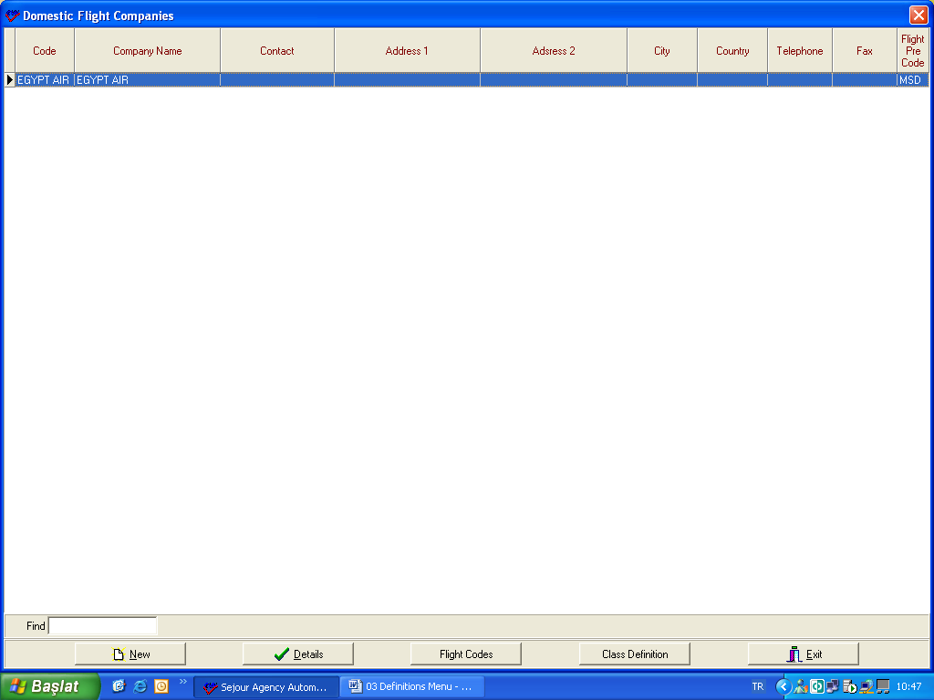

To be able to define domestic flight company you should use ‘New’ button.

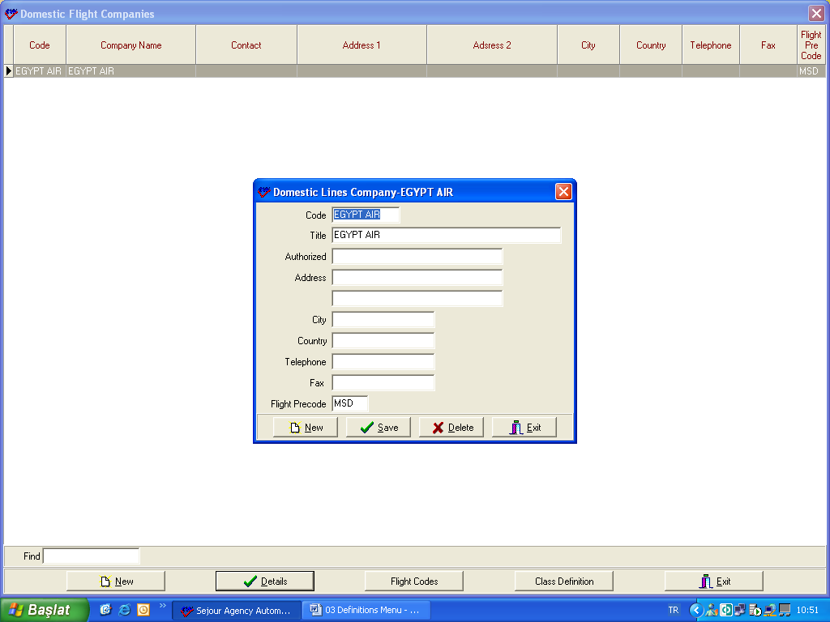

After entering the details about the company , save it.

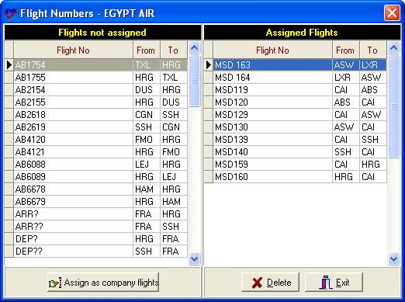

Using ‘Flight Codes ‘ button you should select domestic flight codes that you defined before and assign them using ‘ Assign As Company Flights’ button.
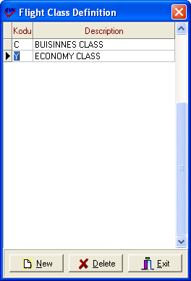

You should define flight class as well.

Transfer Types

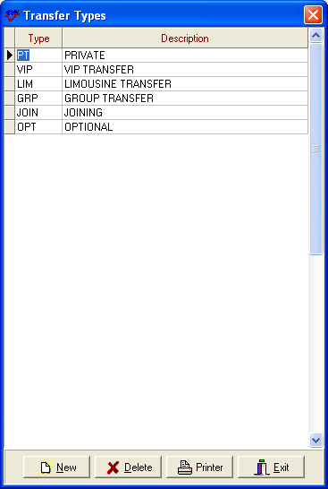

You should define transfer types that will be used in tariffs and operations here .The only thing that you should is to enter short code and write the explanation.

Handling Fee Type Code

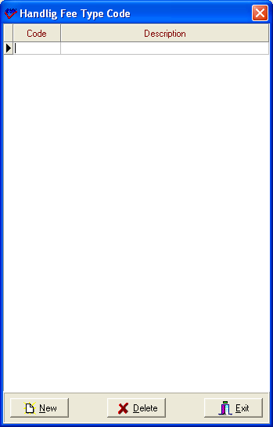

This table is used to defined handling fee types if you have apply different handling fee for different situations .When you define a different handling fee type , you can select this type while you are entering your handling fees in tour operators part.

Guides

Here you can enter details of your tour guides, with qualifications, languages, salary, as well as personal information such as telephone or mobile number.

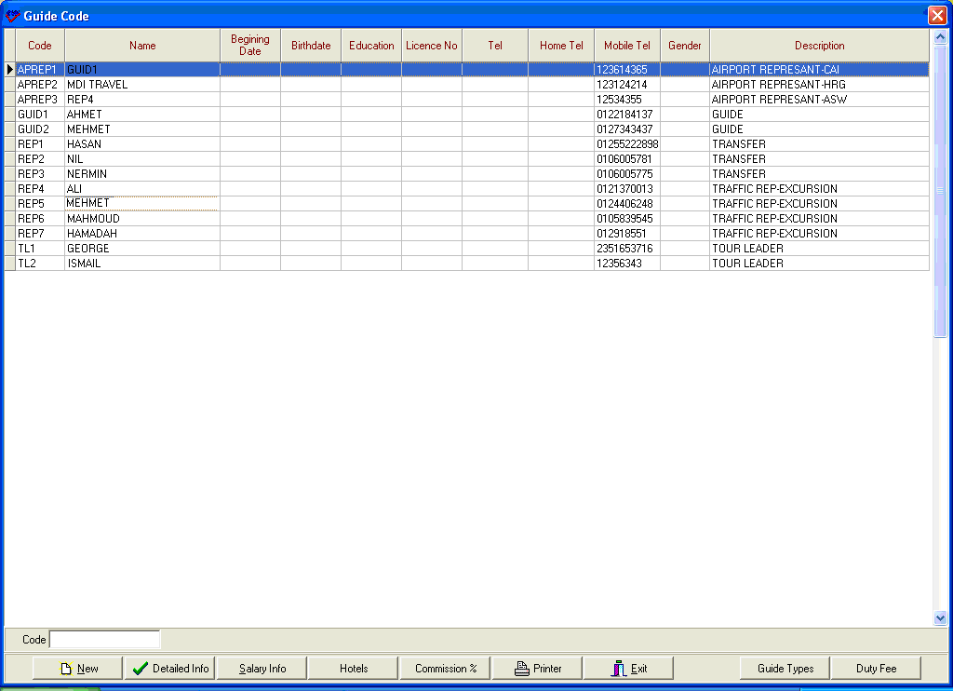

In the function buttons underneath of this screen, you can enter additional data as follows:

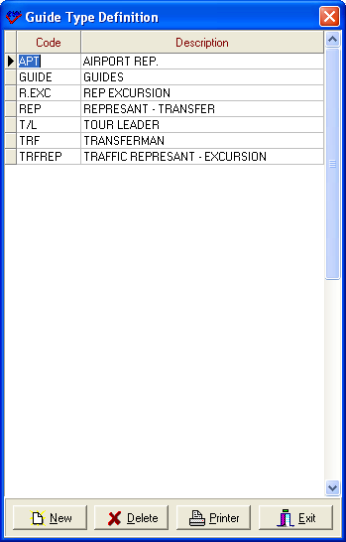

First of all you should define guide types using ‘Guide Types’ button because you will need it defining your new guide.

Detailed Info:

Here you can enter important personal information, such as address, different telephone numbers, languages and other professional qualifications.

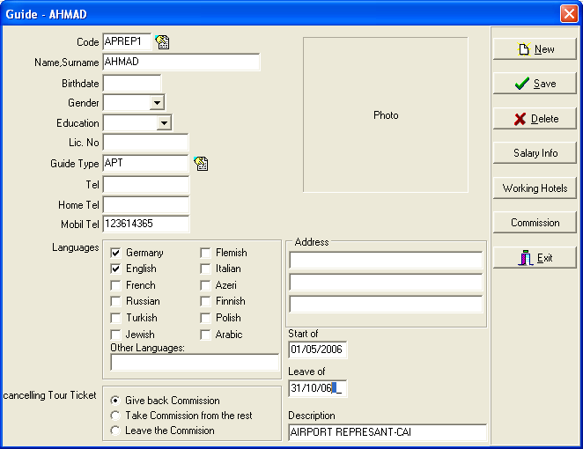

Cancelling Tour Ticket : It’s important to enter the information about how Sejour will handle tour guide commissions if a tour is cancelled. Here the commission has to be returned, if a tour is cancelled.
Salary Info:

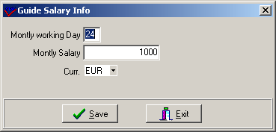

Here the salary is entered in the selected currency. You just enter the salary information of guides .This part is for information.

Hotels:

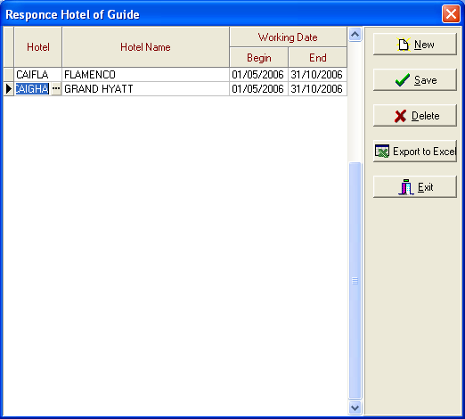

When left blank, a tour guide can work in any hotel. However, you can assign a tour guide to a particular hotel if you wish to. This part is also only for information.

Commission

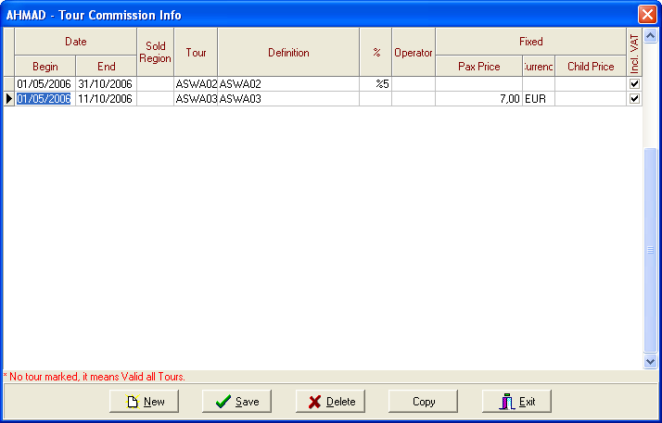

Here you can assign commission for your guides as a percentage, or a fixed sum (with currency) and you can choose whether or not VAT (sales tax) will be added.
You can assign commission fees by date, by tour operator, by region, and by tour.
When a field is left blank, the same commission applies for all values.

Duty Fee.

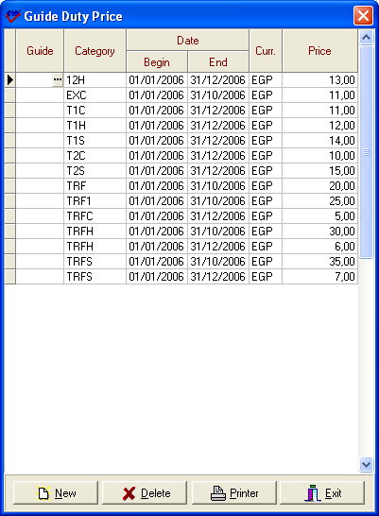
Here you can add any miscellaneous extras to the tour guide fee. The categories are selected from previously entered values (shown below).

Guides Fixed Price Category

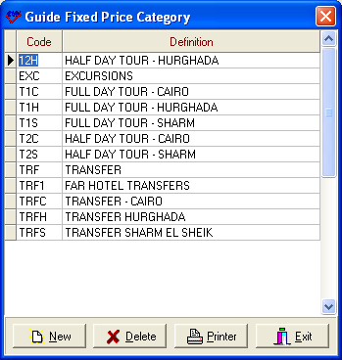

Here you can enter the short codes for the “Guide Duty Price” categories shown above.

Coach Types

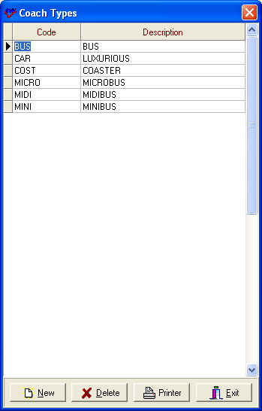

Here you should enter all your different types of coaches and vehicles that you will use to transport clients. You can add more at any time later.
Press the keyboard key “Enter” to start a new line, and the data will be saved automatically.
Coach Companies

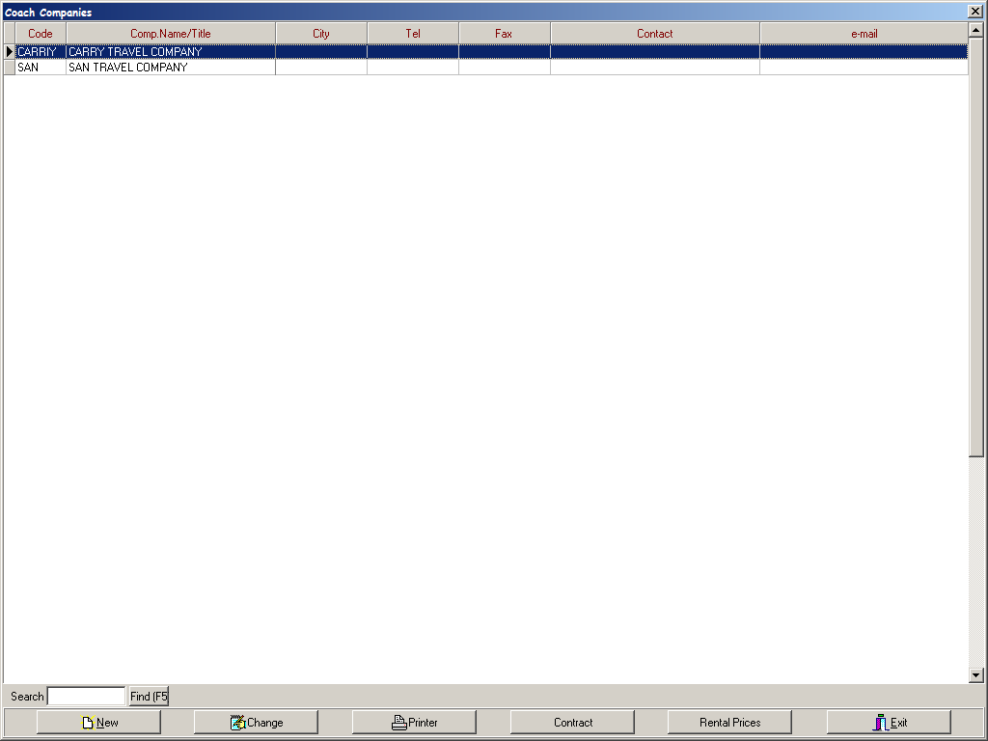

You should define coach suppliers that you work with or your own company if it has own vehicles in coach companies sub menu .To be able to define a new one you should use ‘ New ‘ button and enter detailed information.

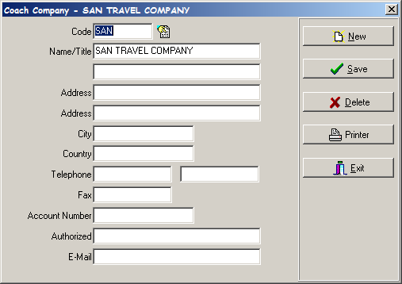

COACHES :

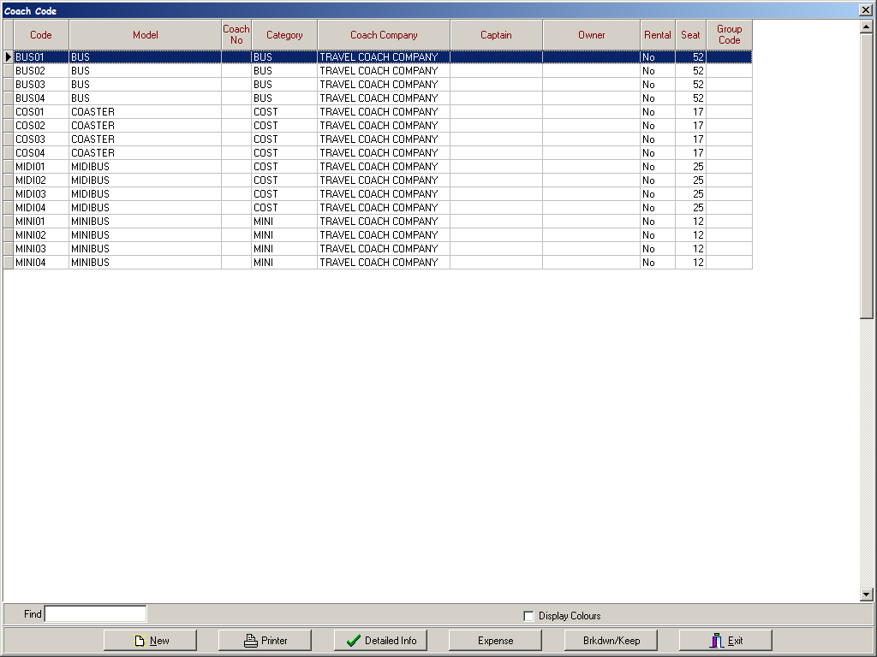

It is one of the most important part in Definitions sub – menu .Because you will define all your coaches and vehicles that you use in tariffs and coach operation for tours and transfers.

Detailed Info:
Using this screen you can enter all the details of specific vehicles (cars, mini- & midi-buses, coaches etc.) Also here you can enter information about fuel consumption.
This definition will probably be more important for tour operators who own their own coaches, and want to enter details of specific vehicles such as licence number and gasoline consumption.

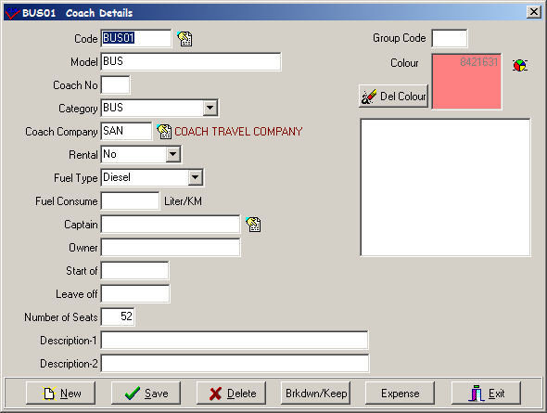

Rental :
It is for specifying whether this car is rental or it belongs to your company.

Fuel Consume:
This information can be used with the “Fuel Prices” definitions (entered later) to calculate how much it costs to run a given coach or vehicle and calculate profits in tours, for example.

Expenses:
Here you can maintain and enter a list of running expenses due to consumables such as parts or servicing. These costs will be used in reports of costs and expenses.

Brkdwn / Keep :
Here you can keep a log of vehicle problems and repairs to help you identify potential problems ahead.
This screen function is for text comments only, and any cost information should be entered in the “Expenses” menu.

Colour:
You can use user-defined colours for each coach so that you can recognise coaches easily in large lists.

Drivers

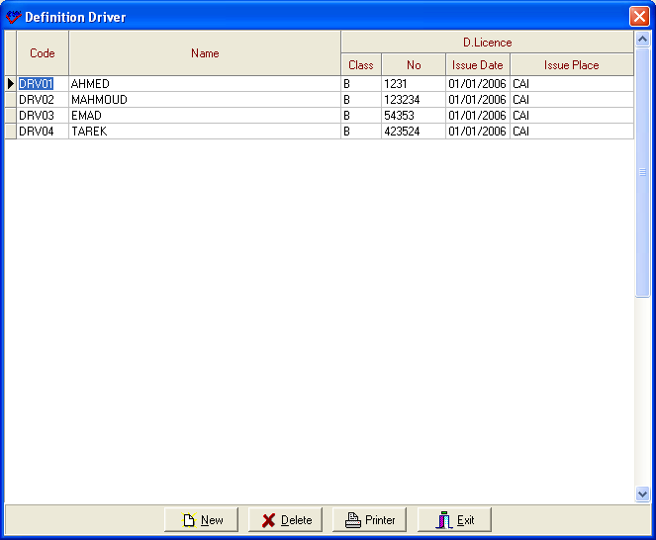

Here you can enter details of your drivers who work for you and their driving qualifications. Once entered, these drivers can later be assigned to specific jobs, or coaches

Fuel Oil Prices

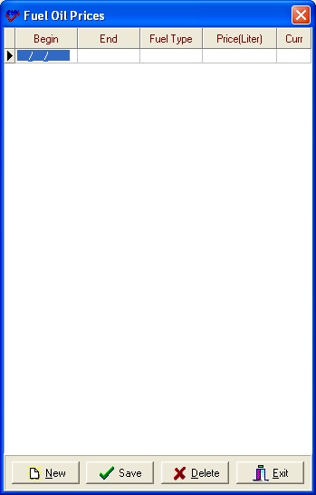

If you enter fuel consumption in coach table and when you enter the price of fuel–oil price here with dates , the system will calculate your fuel-oil cost .

Here dates are important because of cause fuel prices can vary over a season.

Transfer Expenses

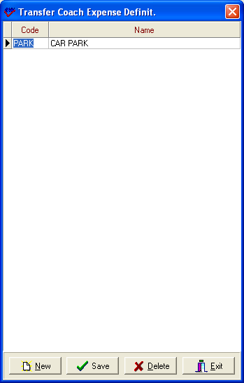

This part is to define expenses made during transfers.

EXCURSIONS

Setting up the tours menu has to be carried out in the correct sequence. For instance you can’t enter tour prices unless you have already defined which currencies you are using or what your services are. You need to have entered all the above definitions before you can start entering information about tours.

First Step is to define ‘Extra Commissions’

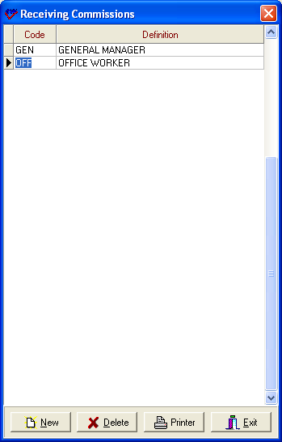

You should define the persons who are receiving commissions except guides. When you enter your tour reservations in tour reservation page you will see these commission rates in payment table.

Debit Tour Ticket:

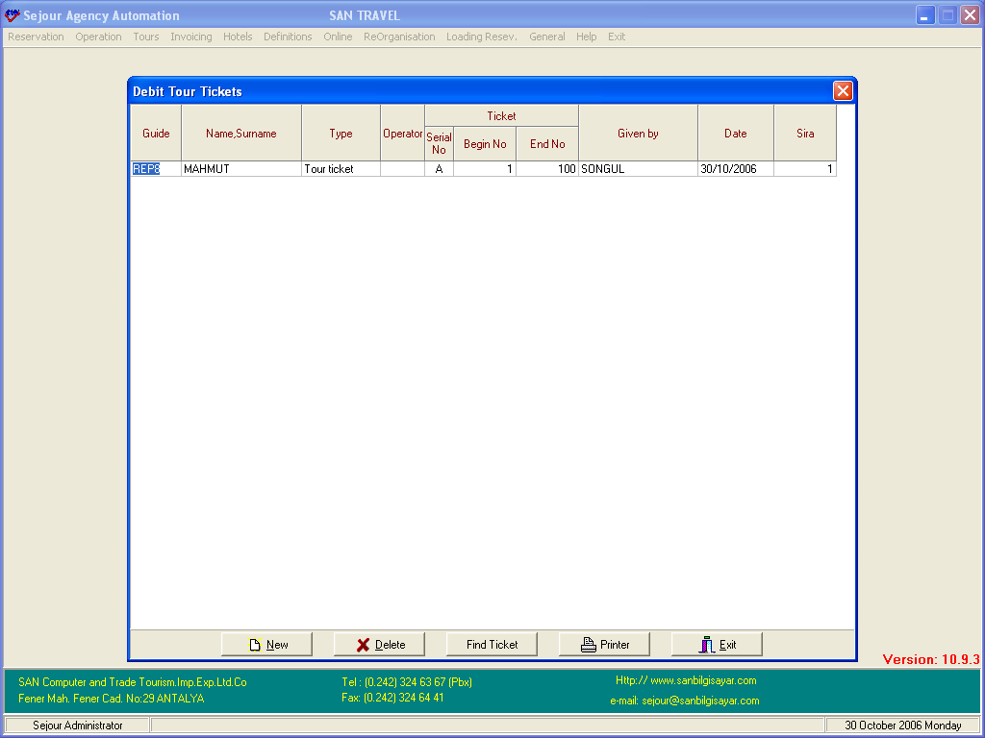

There are two types of tickets (“tour tickets” and “service tickets”).
Here you should debit tour tickets to your guides who are selling tours to clients. When you enter your tour reservations in tour reservation page you have to write serial and ticket number before entering your tour reservation. If the “Operator” field is left blank, the tickets are valid for sales to clients of all tour operators.

Expense Codes

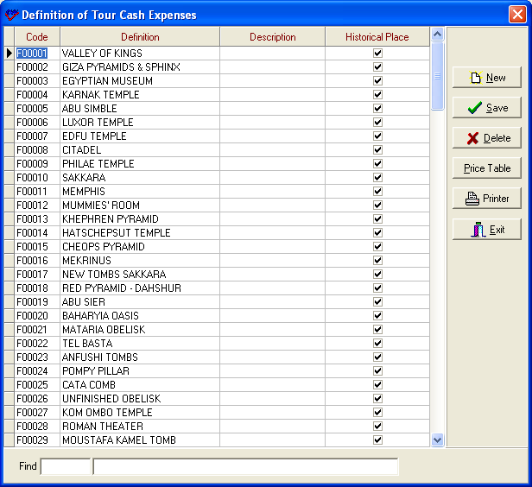

These are usually fixed expenses that have to be given to the guide in advance for generally entrance fees of historical places etc.
After entering short code and full name of the expense you should enter its’ price. When you select a row and click on the “Price Table” you will see a table like the one below where you can enter your prices.

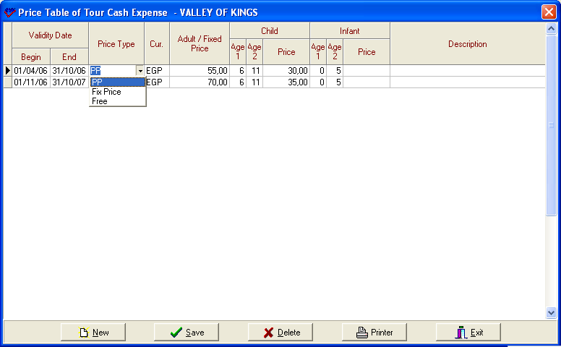

Here you should notice that there are different price types for fixed price expenses, such as car parking, and per person prices such as meals.
You must select a currency from a list, or enter the code directly.
The infant price is blank, which means free in Sejour.
Like all these table entry menus, you can save the data using the “Save” button, or by starting a new line.

Departure Times of Excursions

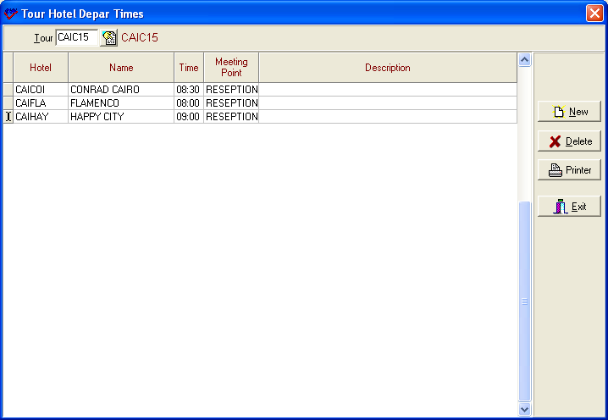

Here you can define the time that clients will be picked up from hotels .First of all you should select the tour and write the time and meeting point where clients will be picked up. These departure times will automatically be entered onto the card when you make a tour reservation.
The times will be used for the coach duty list, the guide duty list, and on any vouchers, information lists that you can post on hotel notice boards etc.

Tour Service / Extras

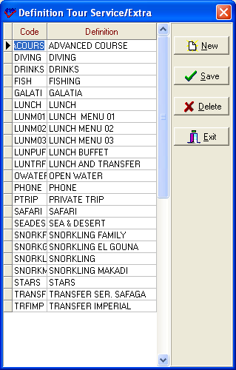

You can enter any services or optional extras associated with a tour, such as lunch , drink etc, here because they will be used entering suppliers prices. You can always add more later if necessary.

TOUR SUPPLIERS:

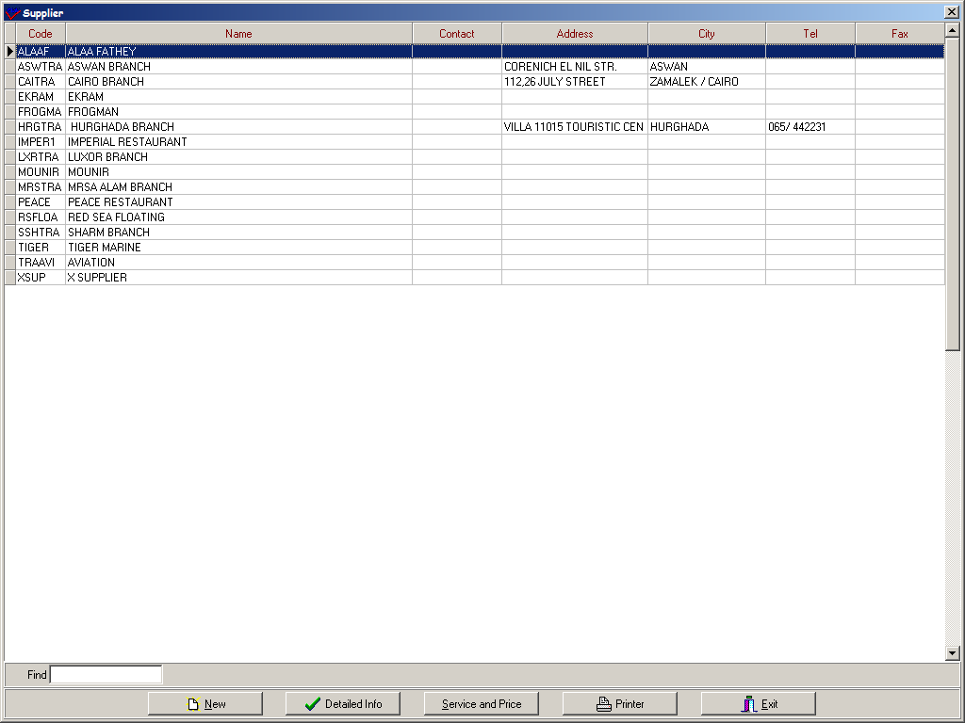

You can define your suppliers and their services with prices who you work with .The information that are entered here will provide you to see the costs of tours on ‘Expenses’ page in Tour Reservation page.
First of all you should define your supplier using ‘New’ button and to be able to define the prices you should use ‘Service and Price’ button.

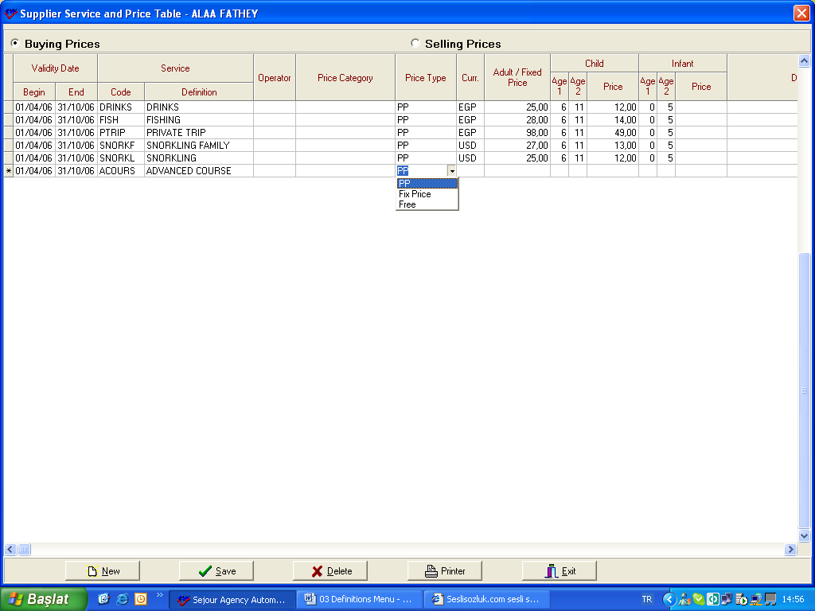

After entering begin and end date when the price is valid , you should select the service by short cut key F2 .If this price will be valid for all tour operators you should leave the operator blank and second point you should notice that is price type. You specify whether service price is per person such as meal or fix price such as car park. You can also enter your selling price in ‘Selling Prices’ part .Repeat this for all of your suppliers, if you want accurate tour profit performance information, and if you want to check your suppliers’ invoices against services provided.

TOUR AND PRICES :

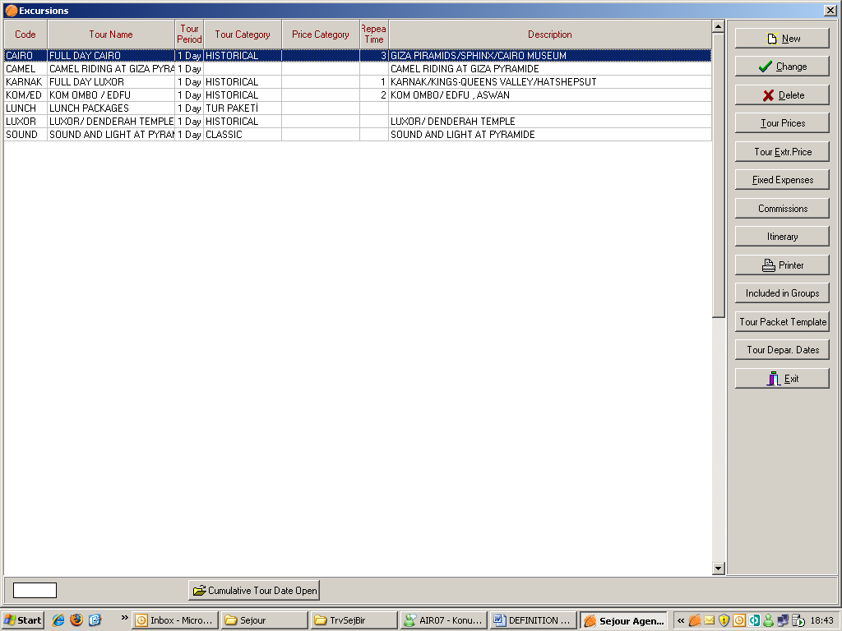

This part is used to define your tour codes and tours .When you define them once , you use them while you are entering tour tariffs and tour reservations.
To be able to set up a tour you should use ‘New’ button as usuall in Sejour.
When you create a new tour, or edit one using the “Change” button, the same buttons are available from that screen, to allow fast entry of information, although it can seem confusing at first.

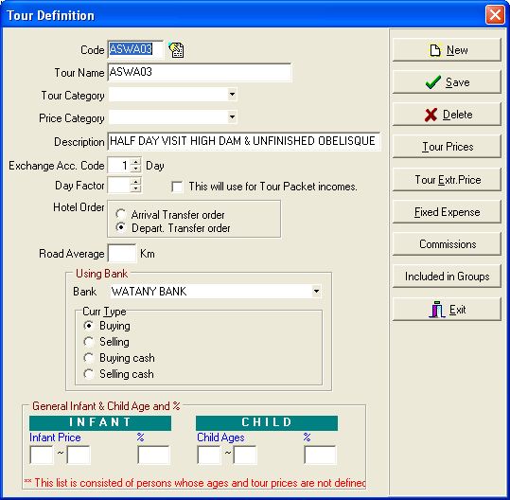

The Code “ASWA03 ” is a short code you can enter to allow fast entry of reservations.

You can write the full name of the tour will be used on request forms , invoices and tour reports in Description part .

“Tour category” can be left blank, or you can enter a category name. As you enter categories, they will be added to the list of categories, which can be letter selected from a drop-down list.

The “Exchange Acc. Code” is actually the number of days for which the tour takes place. Later in this manual we will show you how to set up a tour itinerary.

The “Day Factor” is used for parts of a day, and you should select the box if you need to use these part days in tour packet incomes.

“Hotel Order” is used to determine the order of collection of clients when requesting coaches.

The “Road Average” is the average distance in km that the coach will travel during the tour. If you have entered coach fuel consumption in km/litre, you can calculate the approximate contribution to the cost of the tour due to fuel/diesel.

Bank and currency exchange details can be entered here.

Children’s ages entered here are important for reports and PAX information, and should be entered here. Later, you will see that you can enter different ages for children’s prices in another, separate price table.

Press “Save”, and you can enter tour prices, tour extra prices, etc. in the sequence shown below.

Commissions:

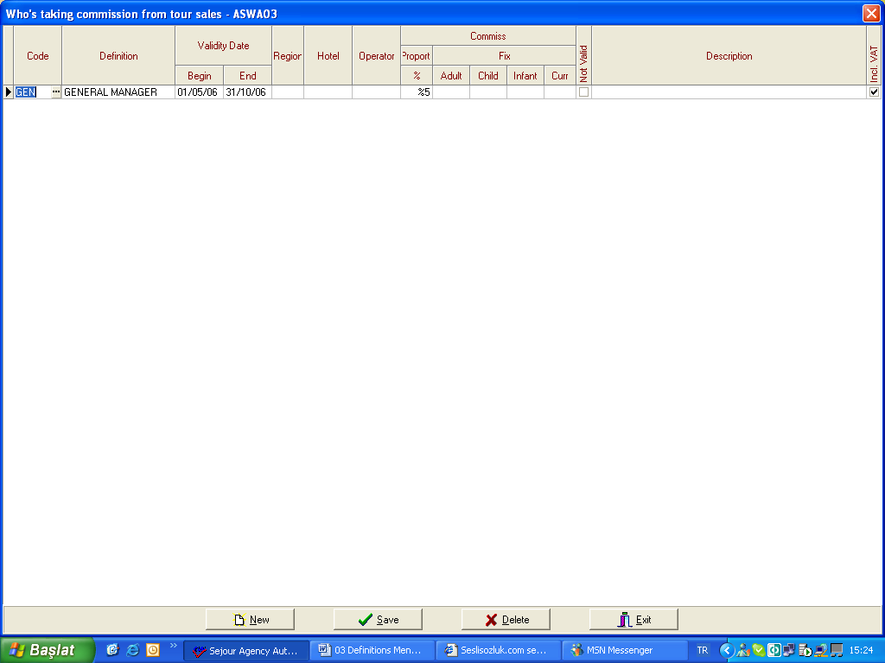

If there is someone who is receiving commission from this tour except the guide who sells this tour you should define it here.

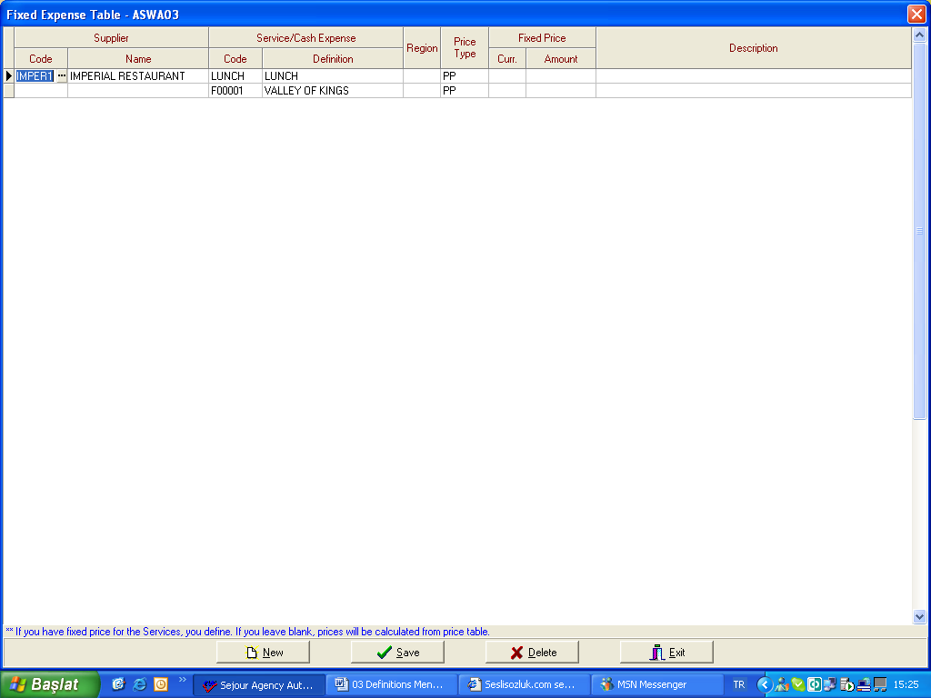

You should enter fixed expenses in this tour here .You should select the code by shortcut key F2 and the code will come from ‘Suppliers’ menu that you entered before and the second point is to select the price type. Since you enter price of this service in ‘Suppliers’ menu, you don’t need to enter it again unless the price changes for this tour.
If the service does not have a supplier such as entrance fee for a historical place you don’t need to select the supplier and you can select the service by shortcut key F2 and this code will come from ‘Tour Cash Expense Menu ‘.

Tour Extra Price

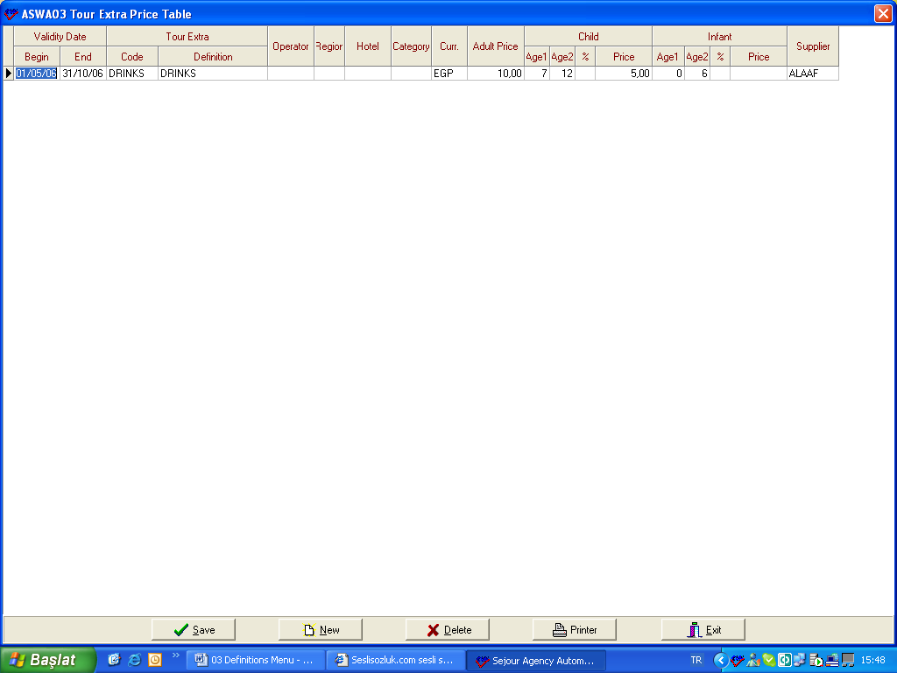

If in this tour there is something excluded and optional for clients you should enter its’ prices here .When you enter tour reservation from tour reservation page if a client demands this extra in this tour you should specify it there.

Tour Prices: If you prepare tour prices according to pax number interval and you enter tour tariffs in tour operators’ part you do not need to enter tour price in this part.
If there is not tour tariffs , the system takes tour prices from this part.

Tour Package Template :

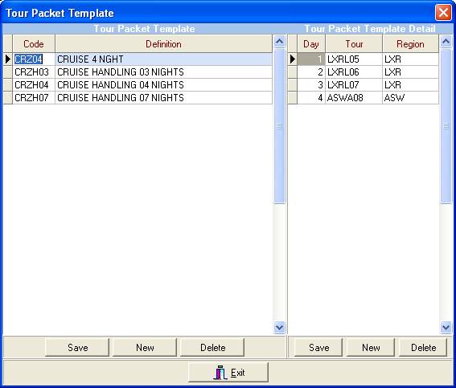

To be able to define tour packets for cruises you should use ‘Tour Packet Template’ button in Excursions page.
After creating a code for your packet you should write its’ definition and in the next table you should add tour itinerary consisting of tour day, tour codes which are included in the packet and region where the tour takes place.

Included In Groups

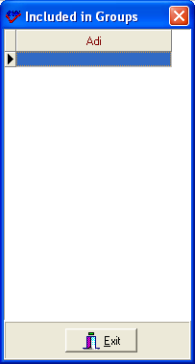

When you form an excursion group in ‘Groups ‘Sub-Menu (will be mentioned in Groups Menu) in order to group tours together and use it in reports and if this tour is included in this group you can see it in ‘Included in Group’ Table.

Tour Itinerary

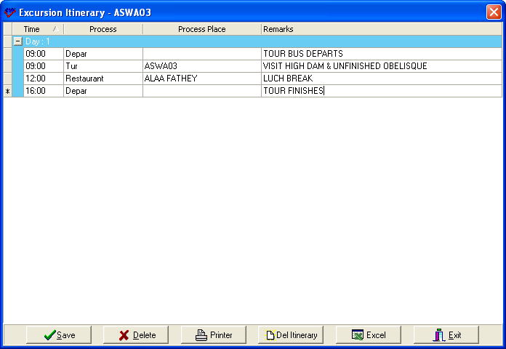

Itineraries are built up using times, selecting processes (or itinerary stage) from a dropdown list (eg info, hotel, departure, etc.)

When you select a specific process, the process place drop down list will automatically update the choices offered. For example, when you select a “hotel” process, the process place will present a list of hotels in the system for you to choose from.

You can enter new itinerary stages using the “↓” or downward cursor, or you can add new stages by using the “Insert” button on your keyboard.

NB. There are two buttons for deleting entries. “Delete” removes a single line from the itinerary, and “Del Intinerary” deletes the whole table!

Printer : Generates a screen display or a hard copy of the tours in your system. If you select the screen display option, you will later be able to save the list as an MS Word file, or an Adobe PDF document.

Additional Services

If you wish to use this ability, there are three important tables that have to be defined in the Sejour “Definitions” Menu.

Rent A Car /Coach Company

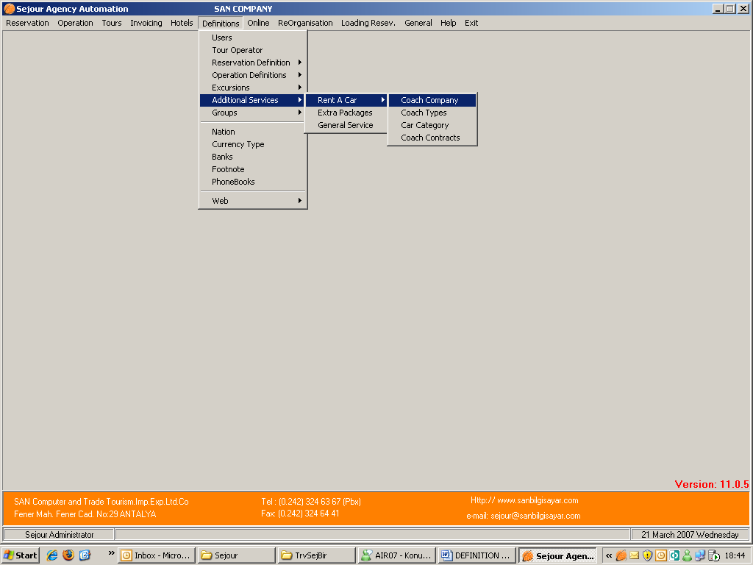

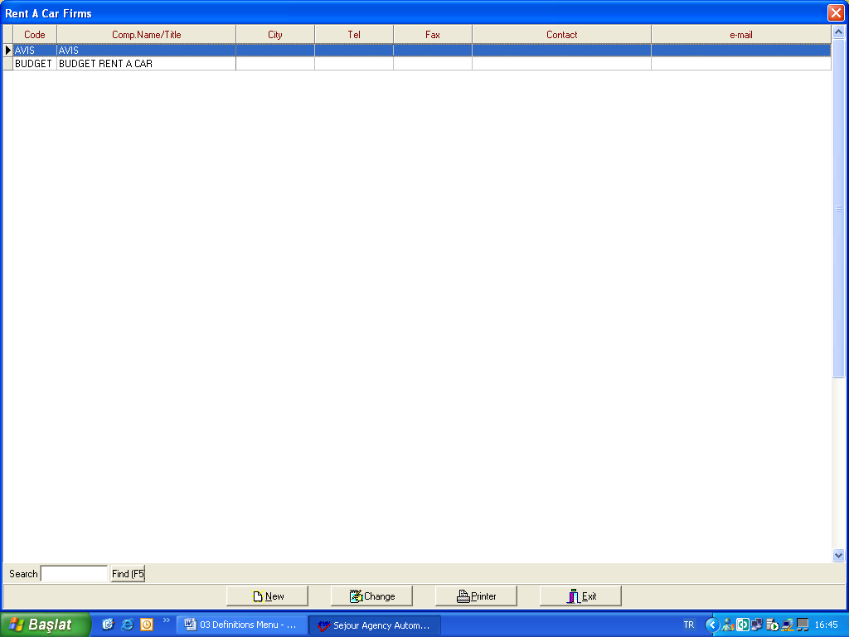

Here you should enter details of the car rental firms you are working with. To be able to define it you should use it ‘ New ‘ button.

Details can be changed/ entered with the “New” and “Changed” buttons, respectively:

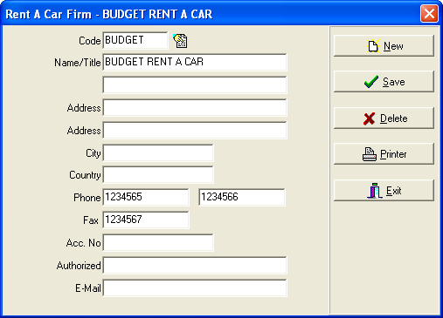

Here there is extra information that is not seen on the summary screen above. To see all this information on one screen (or printout) use the “PRINT” button.

Rent A Car / Coach Types

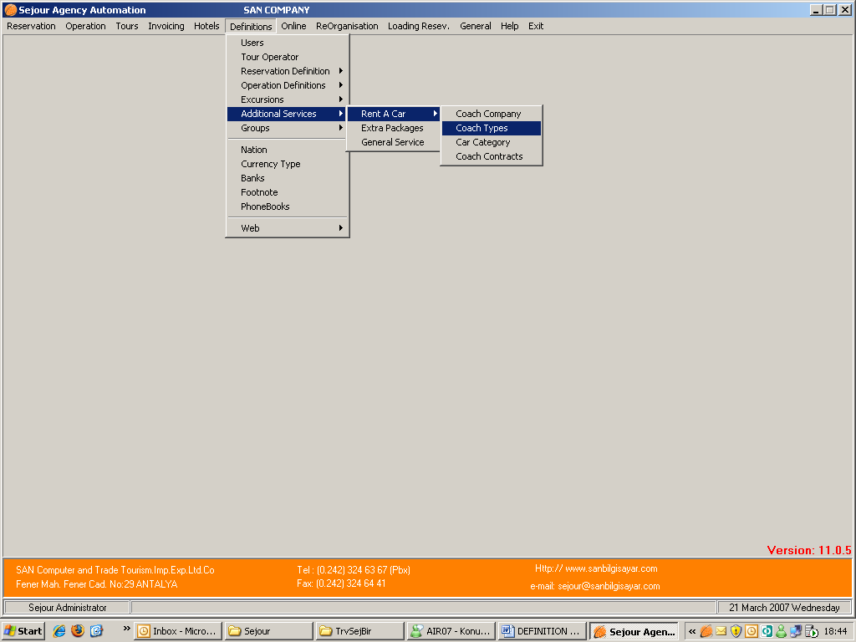

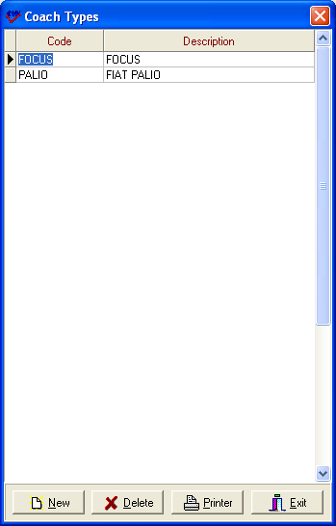

Here you can enter all of the vehicles available for hire from you car rental partners.

Rent A Car / Car Category

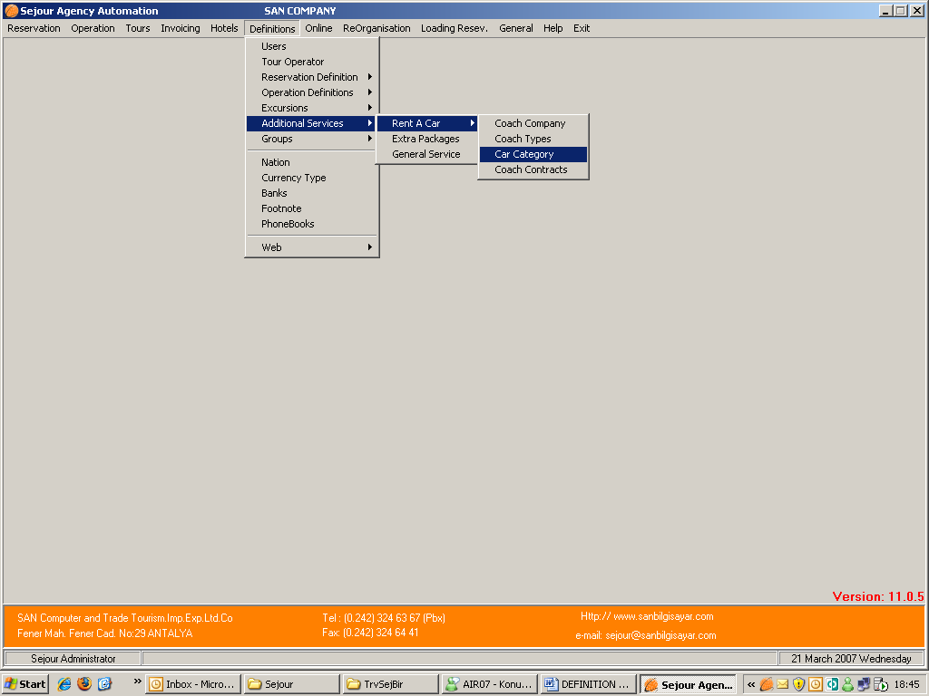

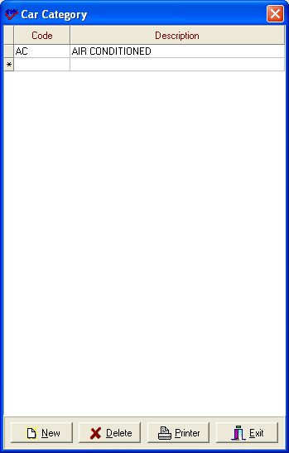

You can write here the feature of cars you rent.

Rent A Car Contracts

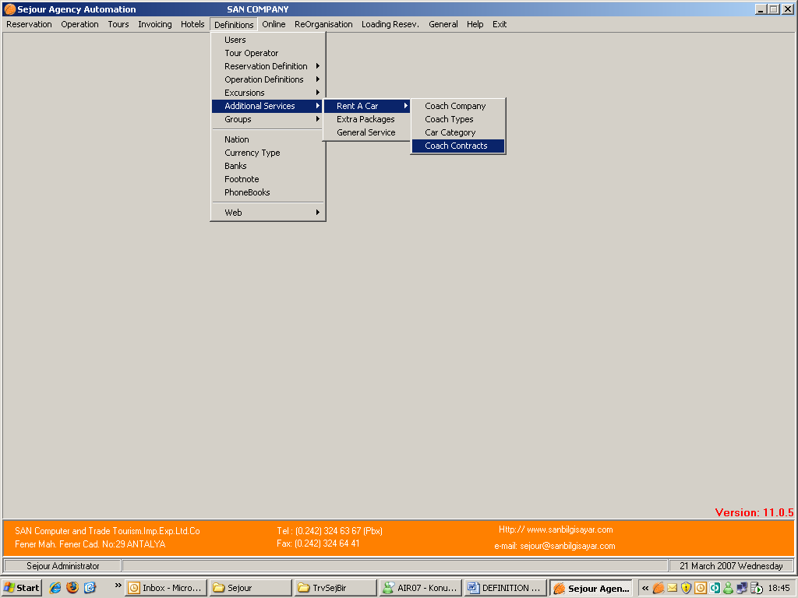

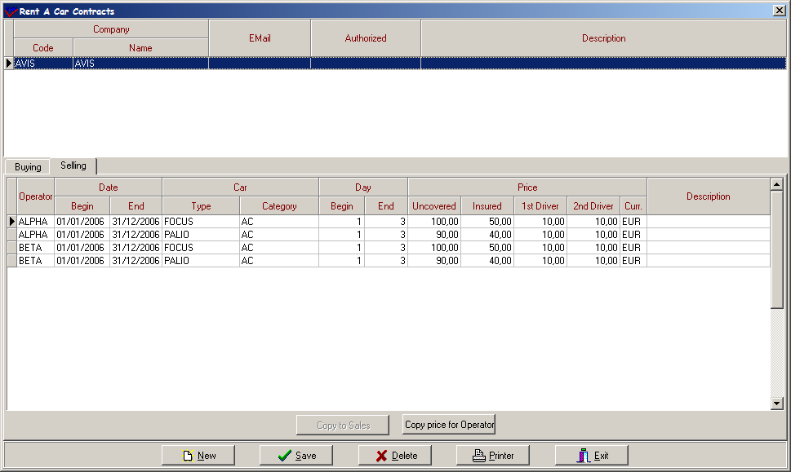

You should enter prices that you buy from Coach Company and sell to your operators. When you select the company above the price part and enter the prices .Entering prices you should especially notice to dates because they are contract validity dates then you should select the car type that you define before. ’Day’ means that how many days clients use the car. In the example above if clients use the car between 1 and 3 days its’ cost will be 100 Euro , if the clients demand insurance they have to pay 50 Euro more and if they wish one driver they have to pay 10 Euro more and if they wish the second one they have to pay 10 Euro more.

Copy To Sales button is used for copying buying prices to selling part so when you enter buying prices when you use ‘Copy’ button you will not have to enter same information to selling price part.

Furthermore you can copy these prices to another tour operator using ‘Copy Price For Operator’ button.

EXTRA PACKAGE SERVICE

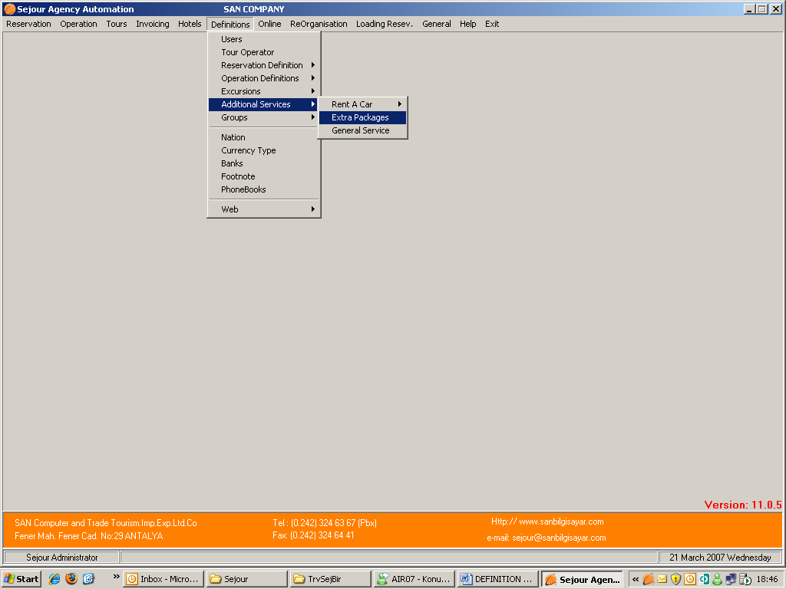

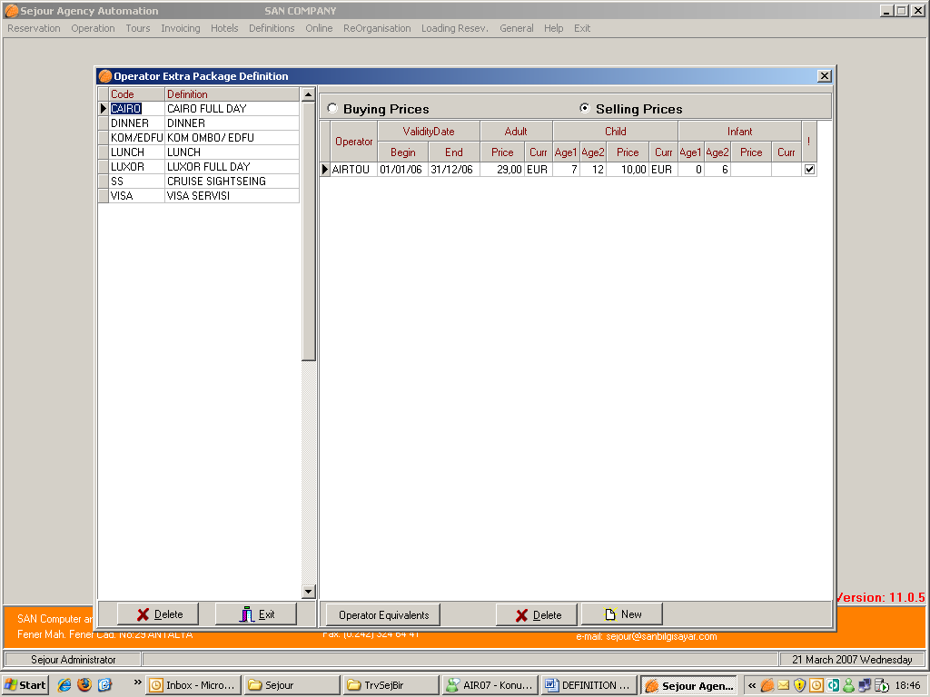

If you have tour packages those are not included in package price, you should define them in this table with their prices.

WELCOME SERVICE/GENERAL SERVICE
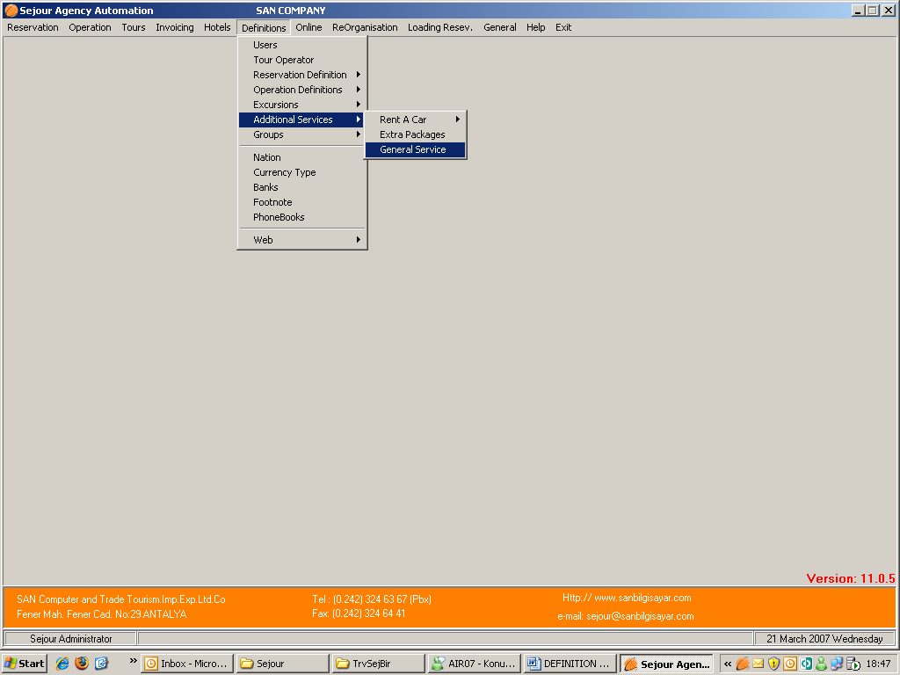

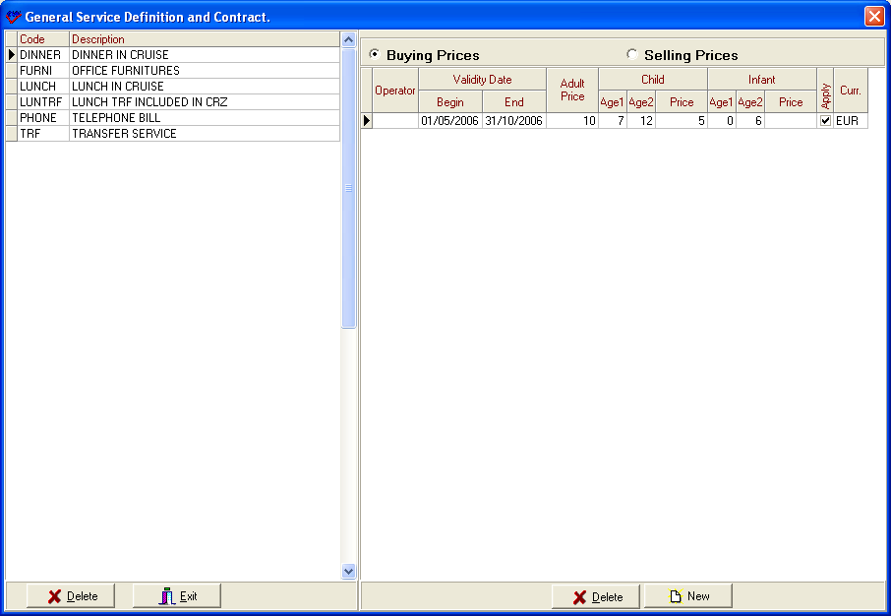

Before entering general services in additional services in hotel reservation page you should define this service here primarily because the codes of services will come to reservation page from this table. When you enter services here, you should define same services in ‘Supplier Menu’ with its’ price. When you enter the service in reservation page and calculate it the system will take prices from ‘Suppliers ‘menu.

GROUPS

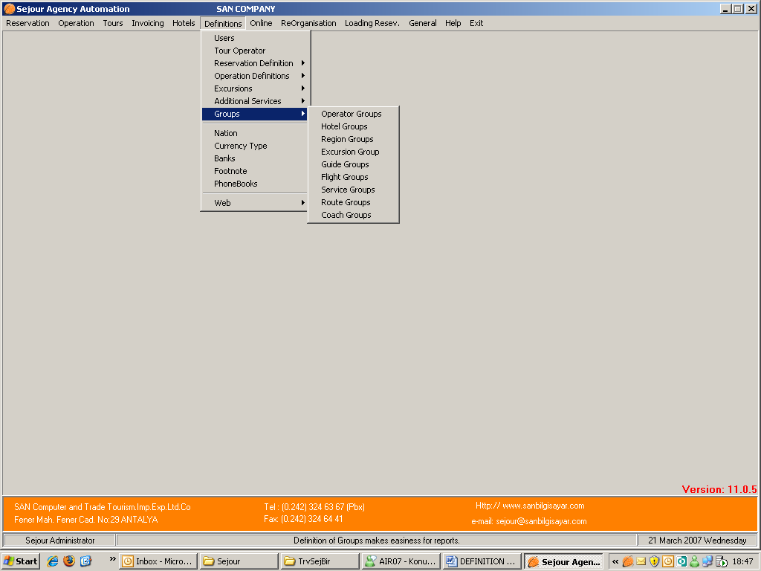

This menu is used for grouping data together such as Operator Groups , Hotel Groups, Region Groups etc. so you can handle or process similar tours, operators or flights as a single unit.

To be able to form a group you should do the followings;

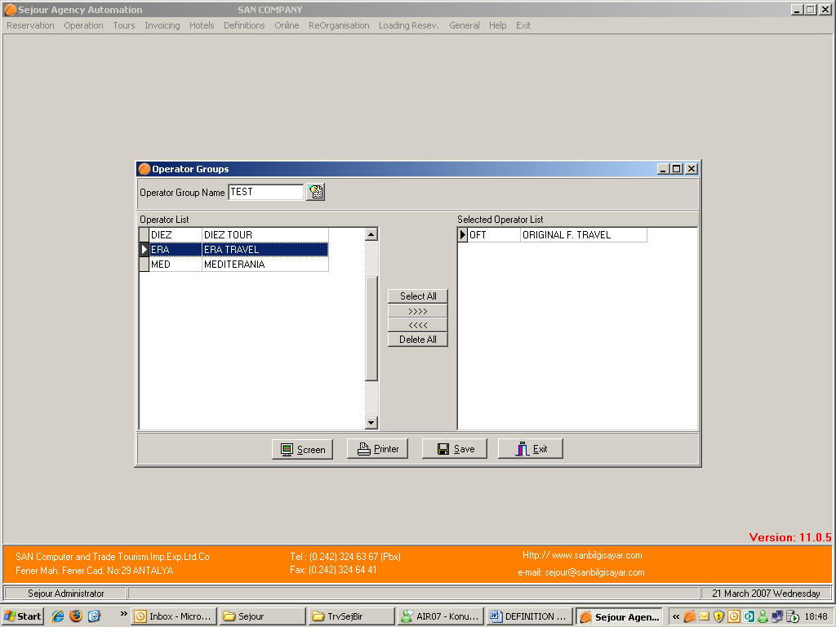

From Groups Menu you should select the group you will form, when the table above ( in this example Operator Groups is chosen) comes to the screen , you should give a name to the group you form. As you see in the example we gave name as ‘ Europe ‘ for operator groups as soon as pressed ‘Enter’ button the system asks a question. If say ‘Yes ‘the system will let you to form the group.
And you start to select European tour operators by using shortcut key F2 as you see in the example below.

After completing to enter tour operators you can take all reports for this operator group.
And this principle is valid for other groups such as hotel , region , excursion , guide , flight , service and route groups.

NATION

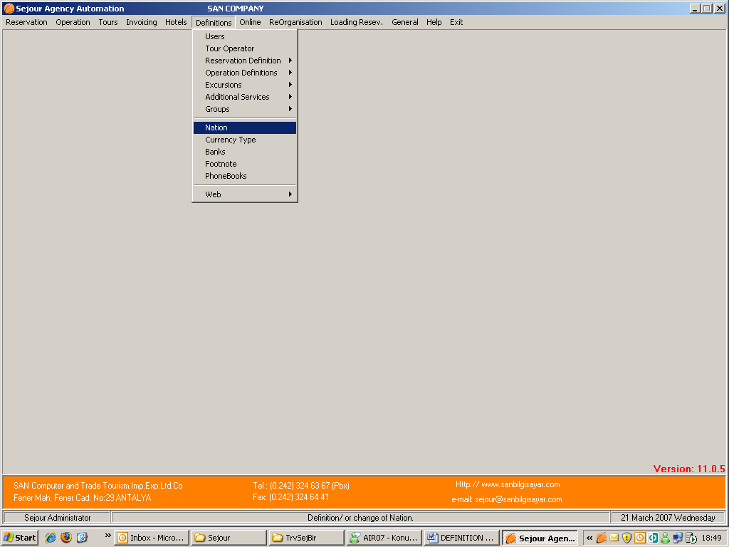

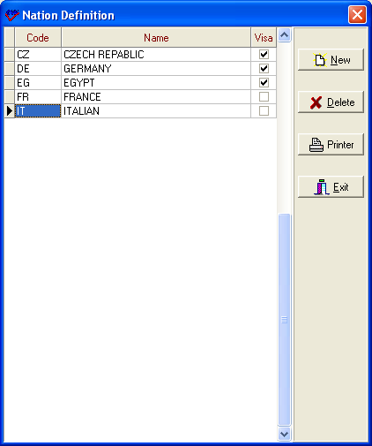

Here it’s important to define all the nationalities of your clients, so when you define tour operator you can define the nationality so while you are entering hotel reservation nationality will be seen on reservation request form. If this nation needs visa service check box should be empty.

CURRENCY TYPE

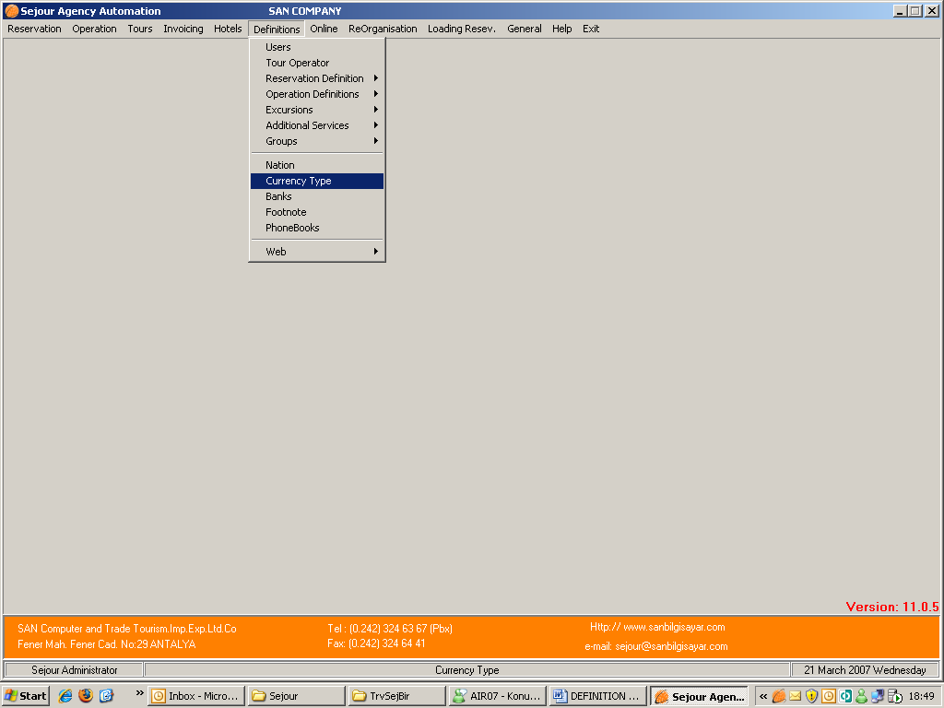

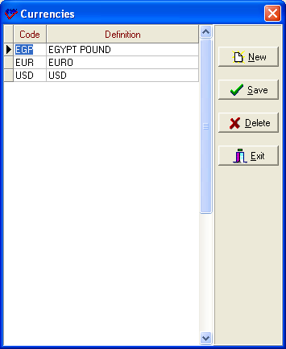

Because currencies are so important to a tour operator, Sejour has a table of short code for rapid entry. Here you can define your short codes and relevant text for each currency used in your system. Sejour supports any number of currencies. You should use internationally recognised 3 letter codes if you want to import currencies from the internet (see “Online”; Chapter 9 of this manual).

BANKS :

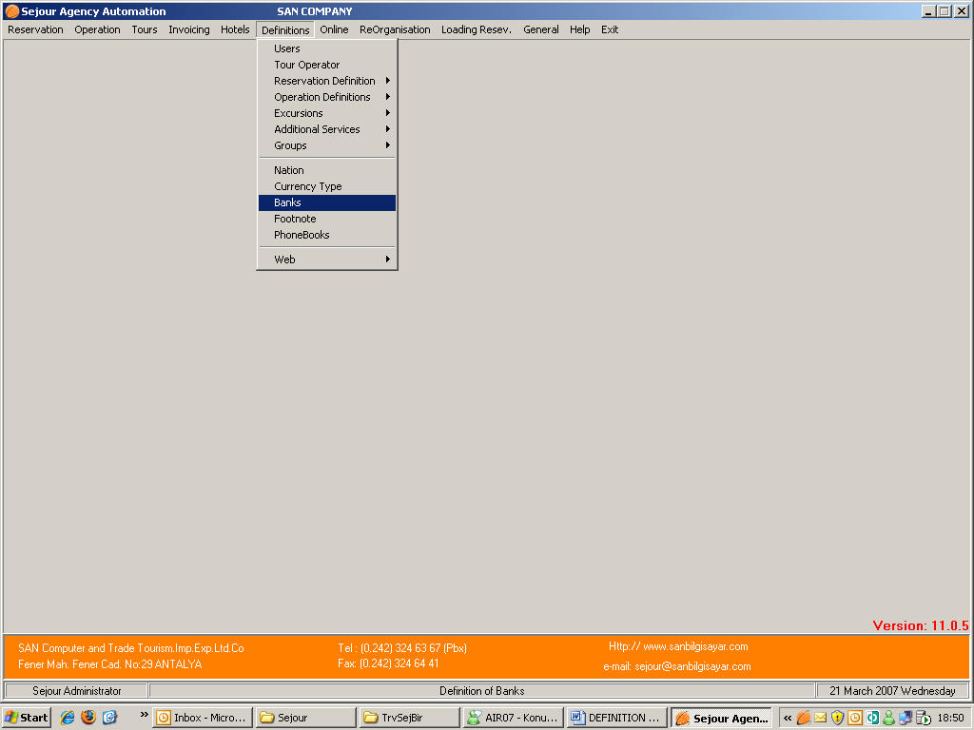

Here you should define banks you work with in order to define your bank in ‘Parameters and Hotel invoice information’ menu so the system will take exchange rate according to this bank.
The only thing you should do is to use for new line and, sequence number and write the bank’s name.

FOOTNOTES

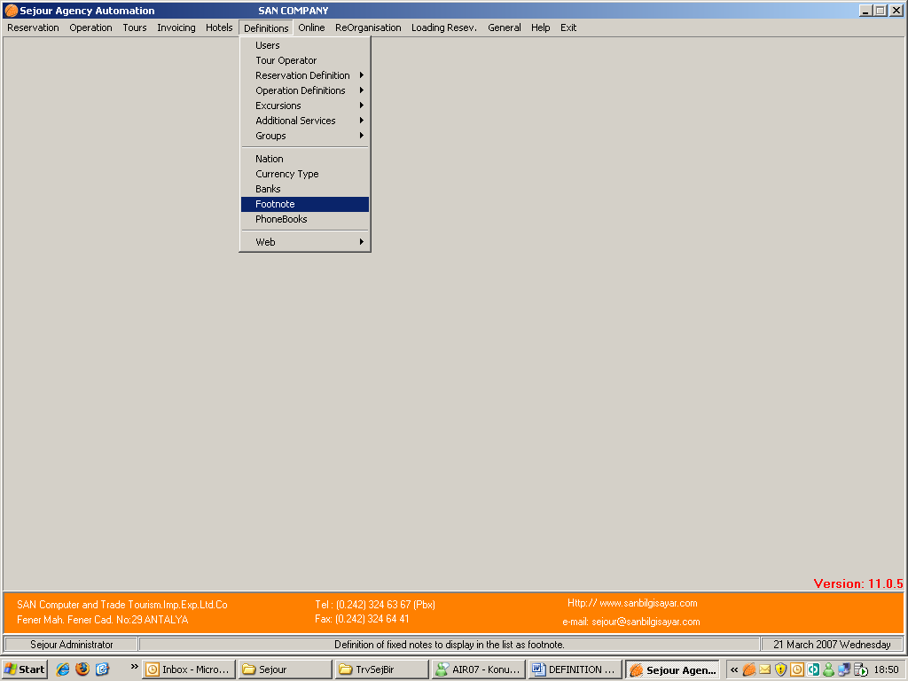

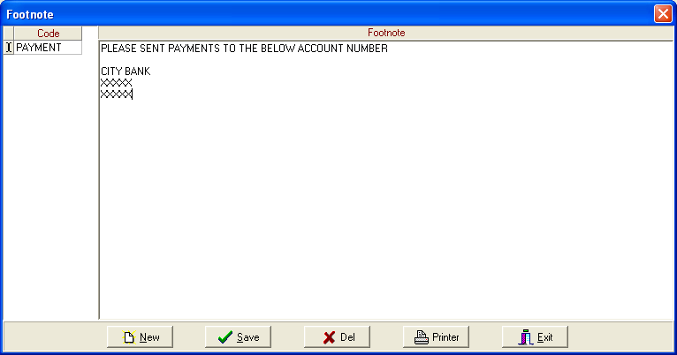

Here you can enter any short footnotes that you want to appear on invoices and reports where you see the ‘footnote’ part.
To be able to write a footnote first of all you should write short code then write full note in the table.

PHONEBOOK

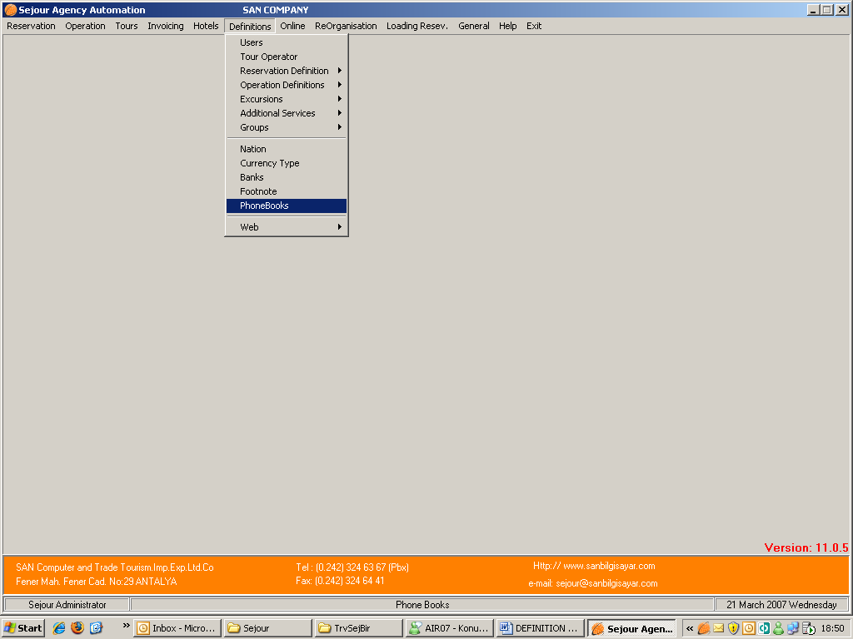

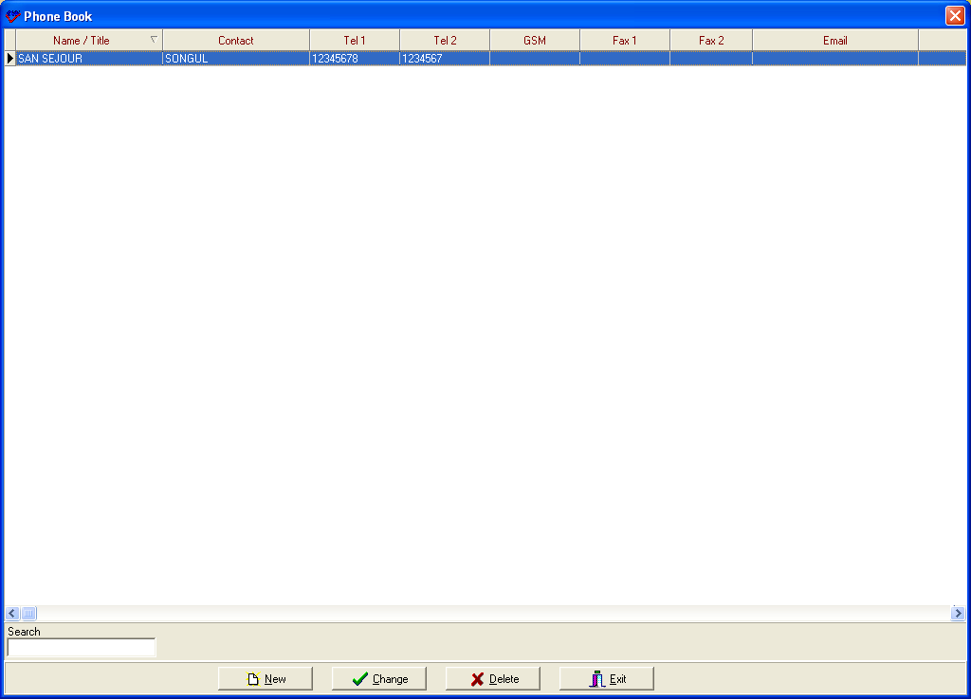

Here you can keep a record of any frequently used phone numbers or other details as below:

Note you can also keep records of partner agencies, hotels, guides, and coach firms in the relevant section of the “Definitions Menu”. The advantage of this menu is that they are all together one a single screen.

